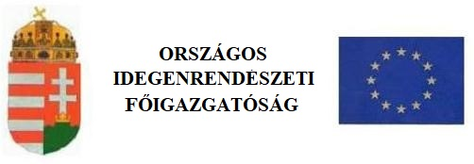
Notifier
In the case of mobility of students

1. Personal data of the third-country national
surname (as shown in passport): |  |  |  |  | forename (as shown in passport):
surname by birth: |  |  |  |  | forename by birth:
mother’s surname and forename at birth: |  |  |  |  | sex:  male female |  |  | marital status:  single married  widow(er) divorced
date of birth:  year month day |  | place of birth (locality): |  |  |  |  |  | country:
citizenship: |  |  |  | ethnicity (not mandatory):
last permanent address abroad:
2. Name of first Member State:
3. Type of residence permit issued by first Member State:
Number:
Validity period: year month day
4. Passport details of the third-country national researcher / family member of the researcher
passport no.: |  |  |  | place and date of issue:  (place) year month day
passport type:  private passport service passport  diplomatic passport other |  |  |  | validity period:  year month day
5. Particulars of host education establishment
name:

registered address:

postal code: |  |  | locality: |  |  |  |  |  | name of public place:
type of public place: | building number: |  | building: |  |  | block: |  |  | floor: | door:
Transaction number of payment if made by electronic payment instrument or by bank deposit:
I hereby declare that all data and information indicated above and in the appendix are true and correct.
Date: ..................................... |  |  |  |  |  |  | .........................................................................  signature

