Béla Szomráky
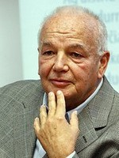
University professor, journalist, translator, former editor in chief of foreign language programs at the Magyar Rádió, a famous and appreciated Italian-Hungarian consecutive and simultaneous interpreter, and last but not least, interpreter of the earthly head of the Roman Catholic Church.

Béla Szomráky is a well-known Italian-Hungarian interpreter who is appreciated not only in Hungary, but also in Italy. He is the owner of three prestigious Italian honors; in 2002 he was awarded the Grand Cross of Honor of the Order of the Star of Italian Solidarity, in 2006 he got the Knight Cross of the Order of Merit of the Italian Republic, and his most recent acknowledgement from Italy arrived in 2013, when he received the Officer’s Cross from the Order of Merit of the Italian Republic. But this is not the end of his remuneration since in 2012 he also received the honor of the Hungarian state when getting the award Knight of Cross of the Order of Merit of the Hungarian Republic.

Early life
Béla Szomráky was born in 1945 in Budapest. He completed his primary education during the period of the Soviet invasion, and according to his words he found himself in such a „fortunate situation” that he received double education. At school he was taught the obligatory ideas of the regime, but at home he could freely speak about Hungary’s real situation.
He graduated from Eötvös Lóránd University (ELTE), at the Faculty of Humanities (in Italian and Spanish).

A passion for the Italian language
His passion for the Italian language is very much connected to love. During the interview, he shared with me a very nice and romantic story, which practically led him to start his career as an Italian interpreter.
„I remember when I first stepped into the classroom. It was the 1st of February, 1960, and I immediately saw her. She was very beautiful and she learnt Italian”.
As a young teenager Mr. Szomráky wanted to conquer the heart of this young girl, called Katalin, so despite the fact that his languages were French and Russian, he took up Italian lessons. Soon he discovered his talent for languages and during the university years he did not only learn French, Portuguese, Russian and Italian but also studied Spanish and Polish.
“Why Italian? It is very easy, I was desperately in love, thus the world of the Italian opera attracted me, and the beauty of discovering the different foreign languages led me toward exploring new experiences”.
Interpreting – Early experiences as an interpreter
“A few years later love crossed my life again, and my destiny was decided in the person of Caterina, a young reviser at ELTE University. Later she became my wife and in 1971, in order to unite our families, I received a passport to immigrate to Italy, to Florence”.
During his stay in Italy, Mr. Szomráky did a PhD at the University of Florence and worked for the CNR (Centro Nazionale delle Ricerche).
Before moving to Italy, he gained experience as a professional interpreter. During the 1960s, he interpreted and translated mainly for businessmen and for the representatives of machinery companies.
Moving back to Hungary
After several years in the amazing Italian environment, Mr. Szomráky moved to Hungary. Later, he started working at the Magyar Rádió, and became the editor in chief of foreign language programs.
“Fortunately, I had a very flexible job at the Radio, so I also worked as a freelance translator and interpreter. I have translated as much as 200-300.000 pages. I have translated several literary works, but the majority of these translations was made in the field of business and trade, and additionally I have to say, that I made numerous contributions to the television and for the film industry too”.
About translation
“Translation is very important, if not essential, to become a professional interpreter. When you are interpreting you need to recognize immediately the grammatical structures, so all the translations that you have done previously are going to help you in order to see, or at least imagine visually the possible ends of each oral sentence”.
About the top of his career
With this topic we have arrived to the most interesting part of my interview, when I asked him about his position of being the interpreter of the Pope.
To my greatest surprise, he gave the following answer:
“In contrary to the popular beliefs, I am not, and I will never be the interpreter of the Pope”.
“The truth is that the Pope has Hungarian interpreters at the Vatican City, but these “interpreters” are priests, who do not really translate the message as professionals do. However, it is absolutely true, that I have always been the person who accompanied all the Hungarian prime ministers (despite their political orientation) to meet His Holiness. I have visited the Vatican many times, and I have a good relationship with Angelo Sodano, who is the prime minister of the Vatican City”.

Memories and working experiences with Pope John Paul II…
Before writing about this exciting period of his life, I must mention that during the university years, Mr. Szomráky spent a lot of time in Poland. It was during these journeys that he discovered the similarities between Russian and Polish languages. Later he profited a lot from his Polish language knowledge as the first episode of his work relationship with Pope John Paul II started when he had the opportunity to talk him in private.
“His Holiness gave me 20 silver medals and a rosary, which are very precious for me. I have been to the Vatican City many times, I don’t even know the exact number of my visitations… Maybe 60 or 70 times.”
About the most important interpreter virtues:
“Discretion is the most important quality of an interpreter. I always thought that it is better to forget the content of what you have interpreted. It is definitely out of the interpreter’s job to remember the secret and confidential information that he heard during his interpreting service. The interpreter’s job is to make the maximum effort to transmit the message, and it is important to not to forget about the fact that you are present at the event as an interpretation service”.

Final point: advice to young interpreters, as well as pointing out the 3 most important tips for the future colleagues:
Mr. Szomráky believes that it is essential to study throughout our life, especially for interpreters, and he quotes the famous Hungarian saying: A good priest learns until his death. Strongly connected to the essence of this saying, he believes that it is not enough to reach a good and stable level of language knowledge, but one always has to practice and improve his/her knowledge.
“I believe that young would-be interpreters must read a lot and not only in foreign languages, but also in their native, Hungarian language. Those who can speak the language of Jókai and Mikszáth, well, those people can translate really well! Read the news online, and watch television in order to be up-to-date on the foreign countries’ political and cultural situation! But the most important thing is to be able to speak Hungarian. A good interpreter must speak very clearly and nicely in his/her mother tongue. I believe that it is better to deliver the message with little modifications, than to deliver “sick”, meaningless and inconsistent sentences”.

Therefore the three most important pieces of advice of Mr. Szomráky are the following:
- Learn, Learn! (or учиться, учиться!- as the Russian says)
This is very important because he believes that the more we know, we realize how little we really know.
- Translate a lot! (even if you hate it)
- Read a lot!
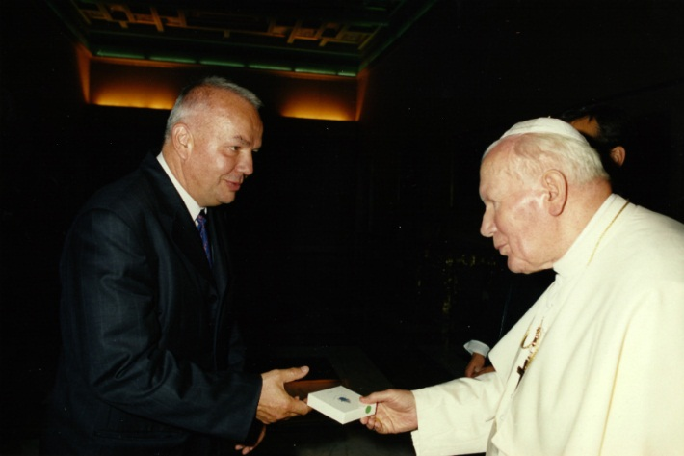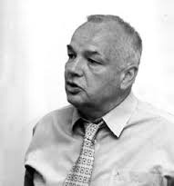
Professional data and references:
- More than 300.000 translated pages, including literary works, poems, articles, Tv and radio programs, screenplays and telescripts
- Most important translations: A társ, 1981, Magvető Kiadó (Cesare Pavese, Il Compagno), A görög filozófia rendhagyó története, 1995, Tericum Kiadó, (his working partner was Mária Peredi), (Luciano De Crescenzo-Storia della filosofia greca)
- Subtitled numerous films, out of which I would like to mention the most recent ones: Short Skin,(I dolori del giovane Edo), 2014 and Long Live Freedom, 2013 (Viva La Libertà)
- Translated the famous Italian Tv series: Nobody returns (Nessuno torna indietro)

Made by Fruzsina Panykó

