Orsolya Bugár-Buday
Orsolya Bugár-Buday
- Freelance translator and interpreter
- European Masters in Conference Interpreting (EMCI)
- Her working languages are: Hungarian (mother tongue), English (B), Spanish (B), French (C)
- CAT tools:
Memoq, SDL Trados Studio
- Causes she cares about:
arts and culture, children, civil rights and social action, education, human rights, politics
- Publication:
„Fordító vagyok – Hogyan találnak rám a megbízók?” (I am a translator – How can I be found by the clients?”
- LinkedIn profile: https://hu.linkedin.com/in/bbotranslator

Orsolya Bugár-Buday is a freelance translator and interpreter. She started her studies in 1984, at ÁMK Elementary School, where she studied Russian and Spanish. In 1992, she continued studying Spanish at Károlyi Mihály Hungarian-Spanish Bilingual High School. Now, she has also added French to her working languages as well as Spanish and English. During her secondary school studies, she acquired a tour guide qualification, which later gave her the opportunity to work as a tour guide at the Hungarian State Opera and to work within Hungary.
In 1997, after she took the secondary school leaving examination and acquired the tour guide qualification, she continued her studies at Budapest Business School. During her university studies, she worked as a tour guide. Since her foreign language knowledge was outstanding, one of her teachers recommended her to apply for the one-year-long postgraduate course of the Department of Translation and Interpreting at the Eötvös Loránd University (ELTE). So she got a degree in translation and interpreting in the fields of social studies and economics. In 2003, she completed the training of European Masters in Conference Interpreting (EMCI). She started her work as an in-house translator at Multi-Data Kft. in 2004. Nine months later, as Orsolya put it, she was in the right place at the right time because after Hungary’s EU accession, she started to work as an interpreter at the European Parliament in Brussels.
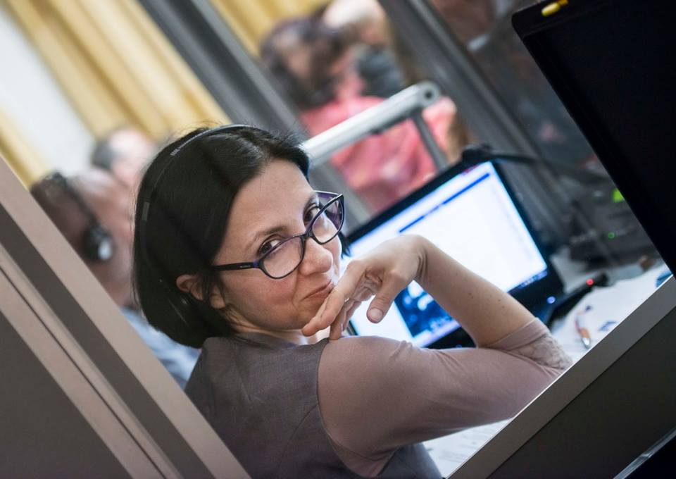
In 2010, her child was born. At that time, she already lived in Hungary but worked in Brussels one or two days a week. Because of the economic crisis, the demand for trained interpreters decreased. The institutions could work properly with employing less interpreters, thus the workload decreased and the job was less profitable. She has been working as a freelance translator and interpreter since 2007 with several partners − European institutions, UN organizations, OECD, ministries, major Hungarian and European translation companies to name but a few.
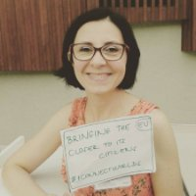
She has been a member of MFTE (Association of Hungarian Translators and Interpreters) since 2003, however she started to play an active role in the life of the association only after the renewal in 2014, when she became a board member. She took part in the editor group of the Cooperation Agreement on interpreting between MFTE and Proford. She was a board member for three years.
Orsolya places a strong emphasis on voluntary work. She started to enroll as volunteer when she moved back from Brussels to Budapest. She encourages everyone to be a volunteer because we can take several advantages from this work whilst helping others: gain experience and expertise as well as meet new people and establish new relationships. What’s more, whilst volunteering, she ended up receiving a paid job. She worked as a volunteer at Háttér Support Society for LGBT People in Hungary, she was an administrator of MFTE’s and ELTE FTT’s Facebook page and she also helped Amnesty International Hungary human rights movement. Besides volunteerig, she takes part in several other projects, for example she translated medical articles for Wikipedia, from English into Hungarian within the framework of the Translators Without Borders organization. She also did several interpreting assignments for the weekly show Newsroom on Hungarian news channel ATV.
So what makes a good translator and interpreter? In her opinion, one of the most important characteristics of a good translator and interpreter is the business approach: even the entrants have to consider their jobs as an investment because it can lead to real success in the future. We should never forget that establishing personal relationships is also essential at the beginning of a career. It is useful to take part in many different professional events. So the other important advice that we always have to keep in mind is that we can learn from everyone.

Written by Petra Krsják

