Profile of Rozália Raulin
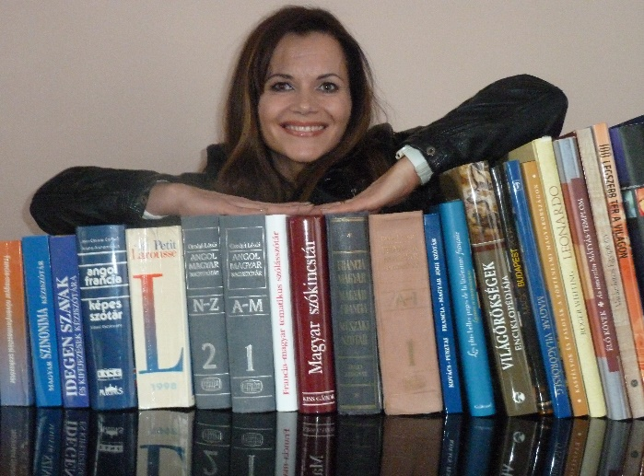
Rozália Raulin is a French-Hungarian/ Hungarian-French interpreter, translator, French language teacher and tour guide. Her working languages are Hungarian (mother tongue), French (C2) and English (B2).
She graduated as a French teacher at the University of Szeged in 1995. During her early years as a teacher she attended two courses. She studied 17th-century French literature which was jointly organised by the Sorbonne Paris IV University and the French Institute in Budapest and attended an intermediate-level foreign trade administrator’s course. After this, she applied to a master’s program in interpreting and translation at the University of Szeged where she obtained a degree in 1998. In the recent past (2010), recognising her clients’ needs she completed a tour guide training course.
These activities are linked to her passion, which by now has become her profession, for communication both in her mother tongue and foreign languages.

I. From the beginnings to present
She became acquainted with the French language at secondary school in Kecskemét. Actually she chose it because she liked the elegant sound of the French language when she was 14. After secondary school she decided to study French at university. Because of this French became her second language (B) and English her third language (C).
During the master’s program she started to work as an interpreter which she continued doing after obtaining her degree. At a time when many national companies were privatised and a lot of foreign companies came to Hungary, interpreters were in demand. Company management could not speak foreign languages well and needed interpreters at conferences and meetings. That is how her career began as an interpreter.
She began to work as a freelancer (self-employed) for a year, later at the recommendation of her accountant she set up her company the Prêt-Inter Language Services Office. Rozália believes it is important to know which form of business is the best for a freelance interpreter or translator.
The tour guiding is the new field she works in. When interpreting on several occasions she was asked to do tour guiding. Initially she turned down these requests, arguing this was a different profession. However, once she accepted such request, tried to perform well. She enjoyed it and after that she decided to learn the profession. To become a tour guide you have to learn techniques different from interpreting and you have to have factual knowledge. Currently she mainly organises alternative sight-seeing tours for the French community living in Hungary. For example, if they are keen to learn more about Attila József, for instance where he lived and what he wrote about, they visit the main sites of the poet’s life together.
Besides these activities, teaching also has an important role in her life. She worked as a French teacher in a secondary school but later moved on. Often translation agencies include teaching in their business activity. Rozália started to teach corporate language courses but it caused too much pressure on her, so she gave it up. But she still gives private lessons when she has the time.

II. Fields and clients
Her clients come from many different professions, including energy, sustainable development, information technology, finance, law, EU affairs, civil engineering, horticulture, dentistry, winemaking, pharmaceutical industry, screenwriting, etc. Her clientele includes multinational corporate groups, small and large enterprises, public institutions as well as private individuals. The majority of Hungary’s most prestigious translation agencies are also among her clients.
Her very first job was with the electricity and gas suppliers, that is, in the field of energy. She has specialised in this field and currently has several ongoing jobs in it. Her other speciality, which also goes back to the beginnings, is information technology because at the end of the 1990s many IT companies offered her interpreting jobs. She really enjoyed this field, so she developed her knowledge and skills in IT.
She has enjoyed special translation tasks in some interesting fields, including recipes, which she found really entertaining because she loves cooking. Once a translation agency asked her to translate a love letter. The dramaturge Zsolt Pozsgai once asked her to translate his play into French. Another culturally related job was her translation of the brochure of the Hospital in the Rock in Budapest by Gábor Tatai, which presents the history of the hospital. She really enjoyed this job.

III. Advices for career-starter
1. Advertisement
At the start of Rozália’s career she did not have to deal with self-promotion. At the time she was working in Szeged and she got her jobs through word-of-mouth recommendations. If one did a good job, they would get more and more work. When she moved to Budapest, she became cut off from her clients, and the university in Szeged. She approached translation agencies, called them, introduced herself and asked if they needed to expand their team and if she could send her CV. Because of this it developed relationship with agencies. As a beginner, it is a good idea to call translation agencies because with these relationships you can start your career and agencies could be your first partners in your clientele.
Rozália believes that it is important to participate in conferences organised by the MFTE and PROFORD which is very active on the translation scene. Also, PROFORD conferences offer heaps of information about the profession and agencies. These occasions offer workshops where you can introduce yourself and it is also a good opportunity for networking. Rozália also recommends using the advantages of the Internet, making a website or joining the MFTE.
She reckons the beginner should not be intimidated by the lack of experience. Translation agencies, for example, welcome interns if they apply. However, specialisation is very important. So if you know which field you like, it is vital to deepen your knowledge in the field. When applying, you should highlight this special field. It is a good idea to have at least 2 or 3 fields of interest and it is certainly not a problem if you have little or no translation experience in those fields. Ultimately, it is qualification and enthusiasm what really matters. Having a business card is very important, so you should get one.

2. MFTE (Association of Hungarian Translators and Interpreters) membership
Because translation is a solitary job, Rozália believes it is a good idea to be part of an organisation where members can recommend each other and which deals with the protection of interests. The MFTE offers a platform where translators and interpreters can share experience, and it affords freelance translators and interpreters a sense of belonging. Through forums, members can immediately ask for help from each another. As a beginner, membership in the MFTE can be useful in asking for help and establishing relationships.

3. Computer-Assisted Translation (CAT) tools
At first Rozália disliked CAT tools but she came to admit that it could not be avoided. Look forward, she decided to learn to explore CATs. Today she believes that the use of these tools is essential; however, it also depends on the type of a translation. Certain types of text do not require CATs. Rozália likes to work with these tools, but she has found that for her they lead to the context becomes a bit unclear. When she has to translate a speech, for example, she would rather not use CATs. However, there have been situations where CATs were essential, for example when she had to translate 2000 easy recipes, and she did not have to type the ingredients every time or the name of a specific species of fish.
She advises not to miss the opportunity if you have a chance to acquire these tools.

4. Work and home
After Rozália started a family, translation assignments came to assume a central role in her professional life because it was more flexible and manageable than interpreting. However, working at home also requires management because you can easily become isolated from outside world.
When she started her career, she had to visit the client for the documents to be translated. It was an occasion when she had to appear in person and it was a different way of keeping in touch. Today there is no such thing. The advantage is that you can spare time thanks to the speed of the Internet. The disadvantage is that you can get lonely. So Rozália set up an office, a separate space in her home. When she goes there it is her workplace, and she can meet her clients there too. It is crucial to separate your home and place of work, even if it is under the same roof.

Closing thoughts

I am very happy to have met such a nice, open-minded, helpful person who shared her life experiences with me, and who likes helping beginners in the profession. This interview was a positive experience and Rozália provided wealth of interesting information.

