Patrícia Beták
„You are what you do”
We first met on the occassion of ’Getting Translated’ conference which was organised by Pázmány Péter Catholic University in April, 2016. I was impressed by her openness, sense of humour and unique personality so I decided to interview her. I could get to know her on our second meeting: various topics were raised, the interpreter’s personality, talent scouting, self-esteem, self-education, the importance of preparation, specialization and even social work and empathy. What’s more, we talked about Cuban dances as she loved dancing in her spare time. Besides dancing, she is passionate about photography.
  - So, let me introduce the incredibly multifaceted then versatile and always optimistic interpreter, Patrícia.
- freelance translator and interpreter
FR - HU
ES - HU

- proofreader

- programme coordinator and associate professor (BME-TFK)

- member of the Hungarian Association of Translators and Interpreters

- representative of the new generation

2012 - | doctoral school, ELTE-BTK Faculty of Arts/Humanities  French literature – Concept of resilience. From silence to creation in Albert Camus’ works/oeuvre.
2007-2008 | postgraduate training programme BME-TFK, University of Strasbourg  Conference interpreting (FR, ES, HU)
2006-2007 | BME-TFK, Marc Bloch University, Strasbourg postgraduate training programme (FR, ES, HU)  Interpreter and translator in Social Sciences and Economics
1999-2005 | ELTE-BTK,  Faculty of Arts  (French language and literature), language teacher
Biography

A lucky accident – or how did her career start?
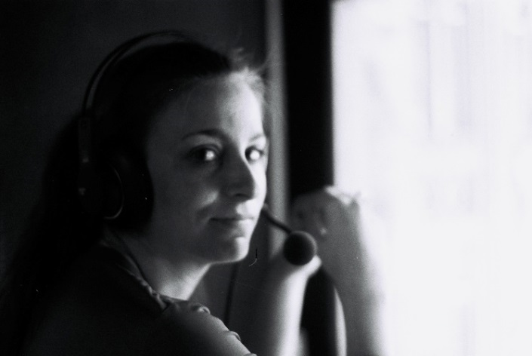
As a child, she had never dreamt about being an interpreter. But fate decided otherwise and by a lucky accident she realised this profession was suitable for her. But where did the idea of becoming an interpreter come from?
During her university studies at Eötvös Loránd University, she participated in the so-called EVS (European Voluntary Service) programme in the framework of which she had the opportunity to learn French and do social work at the same time. More precisely, she was a volunteer governess in an Alsatian orphanage and this experience has been very important to her.
On one occasion, they received a group of Hungarian guests in the orphanage and Patrícia was asked to be their interpreter during their stay. Although it was not that easy for her, she liked it very much.
After she returned to Hungary, she received an official request from another Hungarian group to be their interpreter. She enjoyed this second assignment and was so good at it that she was advised to be a professional interpreter. This was the beginning of her career. She emphasizes the importance of interpreting to social workers during her very first assignments.

What does Patrícia think about her profession?
She highlights the importance of time in several aspects: on one hand, there is too little time to prepare for a given interpreting occassion. On the other hand, the interpreter has to find an immediate solution in a given situation as it is a real time activity. She says it also comes with responsibility and much stress. Due to the fact interpreters have to act quickly, the chance of making mistakes is higher. „It is impossible for us to be perfect all the time– we are humans, not robots. Failure is a corner stone of learning process” – she says.
Besides the difficulties, she mentions quite a lot of positive things about interpreting as well, namely/in particular, its diversity, which means that an interpreter works in various places, meets different people and has to cope with diverse topics so an interpreter’s life is never boring. Her interpreter activities and her educational activities are intertwined but she regards herself as a teacher above all. She is bound up in talent scouting and it is a challenge for her to show students what they are capable of and how far they can get with a lot of hard work.

In the video below, which was made in the Proford conference in October 2015, you can see how she expresses her opinion about the changes of this industry, the new directions set by the new generation and she underlines the time of the new generation will come soon and not only the more experienced generation but the creative younger ones will have a say, too (in Hungarian).
https://vimeo.com/143787561

What is her message to young translators and interpreters?

Firstly, she suggests us to find a professional mentor. It is really important because he/she can motivate us in a way that can determine our career. Furthermore, volunteering in civil organisations is also important because this way, we gain experience and work for a good cause at the same time. Plus, if we ask for feedback, it will boost our professional development.
Patrícia emphasizes the need of self-education as during our university studies, we only learn the basics of translation and interpreting. We therefore have to develop our skills and keep practicing beyond school.
She adds that comparing ourselves to others can take the learning process forward, but we have to be aware of our competences before doing so. Otherwise, our self-image can be pushed in the wrong direction.

A realistic self-image is half success
We have to focus on what our strengths are, what we have to improve and how we can do our best in a given situation. After that, we can face challenges confidently. It matters a lot – it is half success!
Go for it!
Made by
Józsa Judit
PPKE-BTK
Fordító és tolmács MA
2016

