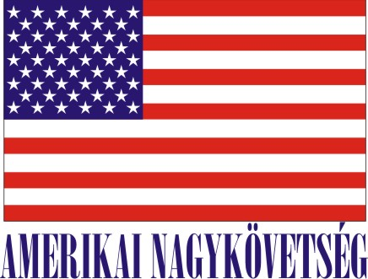
American Embassy Budapest
is seeking a highly motivated student for a
Local Internship
(unpaid internship)
in the Human Resources Office in the Fall 2021

- Duration:
20 hours per week (variable hours) for six weeks.

Major duties and/or projects, the scope of work and related duties:
Variety of projects to include assisting with Awards program, managing files (physical and electronic), may help with administering language tests, scheduling interviews, following up with applicants regarding missing documents, updating SharePoint, filing/scanning documents, creating fillable documents, etc.

Required qualifications to include:
Language Hungarian/English
Knowledge, abilities, and skills required Computer skills, Microsoft Office, SharePoint

How will this internship benefit the section and the intern:
The internship program is a great opportunity for the interns to work in a professional environment together with Hungarian and American colleagues. The intern will also have an opportunity to master his/her communication skills,
Section benefits from additional Hungarian speakers; interns benefit by learning about how the Embassy works, learns about human resources from within the section, and will have an opportunity to be exposed to broad range of HR project. The HR Office will benefit from the interns’ fresh academic knowledge, their creativity, as well as computer skills.
Certification: The Human Resources Office has the adequate workspace and equipment for the interns to perform the duties during the internship.

How you apply:
Submit your application form (obtained from your university) along with your CV, Statement of Interest, and certification of active student status to the Human Resources Office at the American Embassy, Szabadság tér 12. 1054, Budapest or to budapestrecruitment@state.gov.
Closing date: August 15, 2021.
Please note this internship is unpaid.

