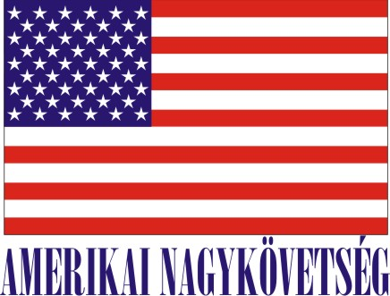
American Embassy Budapest
is seeking a highly motivated student for a
Local Internship
(unpaid internship)
in the Customer Service Center (CSC) for Spring/Summer 2020
- Duration:
20 hours per week (variable hours) for approximately 3 months.

- Major duties and/or projects, the scope of work and related duties:
- Assisting with the Arrival of Diplomats:
- Residence permit application procedure assistance (filing, copying, taking photos, sorting forms, corresponding with the Ministry of Foreign Affairs)
- Collecting different HR, Finance and residence permit related forms prior to arrival
- Setting up Check-In appointments for newcomers
- BKK QR code requests
- Setting up bank account opening appointments
- Assisting with ordering internet/phone/cable subscriptions
- Assisting with Third Party Liability Vehicle insurance policy with service provider
- Collecting/submitting/assisting with VAT refund packages/Translations/Delivery etc.
- Preparing Army base cards
- Assisting with official visa applications: traveler data collection, visa supporting letters, Diplomatic Notes to Embassies and Consulates
- Updating car insurance/technical inspection records and sending reminders to Diplomats
- Assisting with Residence card and passport expiration tracking
- Collecting/scanning/filing Gym Waiver forms and others
- Keeping the CSC Intranet site up-to-date

- Assisting with the Departure of Diplomats:
- Assisting with cancelling internet/phone/cable subscriptions, bank account termination, Third Party Liability Insurance Termination
- Collecting Check-Out sheets and registering forwarding addresses

How will this internship benefit the section and the intern:
The internship program is a great opportunity for the interns to work in a professional environment together with Hungarian and American colleagues. The intern will have an opportunity to master his/her communication skills, to learn how the embassy offices operate, start to understand the aspect of diplomatic and international relations and collect information to the mission community. The CSC Office will benefit from the interns’ fresh academic knowledge, their creativity, as well as computer skills.
Certification: The CSC Office has the adequate workspace and equipment for the interns to perform the duties during the internship.

How you apply:
Submit your application form (obtained from your university) along with your CV, Statement of Interest, and certification of active student status to the Human Resources Office at the American Embassy, Szabadság tér 12. 1054, Budapest or to budapestrecruitment@state.gov.
Closing date: January 24, 2020.
Please note this internship is unpaid.

