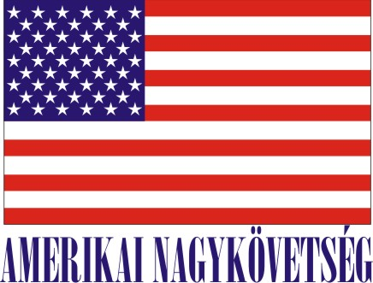
American Embassy Budapest
is seeking a highly motivated student for a
Local Internship
(unpaid internship)
in the Facility Management (FM) Section in the Fall 2019

- Duration:
2 months (with possible extension),
20 hours (3-4 hours per day or every 2nd day, variable hours

- Major duties and/or projects, the scope of work and related duties:
The intern will assist Facility Management Office in miscellaneous office work, will have an opportunity to master his/her communication skills, to follow and learn the frequently changing laws, regulations and collect information.
- Skills/related studies required to perform the internship, including any special requirements/qualifications:
Fluency in English and Hungarian, good communication skills, good interpersonal skills, and computer skills (world/excel, outlook).
- How will this internship benefit the section and the intern:
The internship program is a great opportunity for the interns to work in a professional environment together with Hungarian and American colleagues. The intern will learn how Facility works/serves residences /offices such of repairs/schedules/preparation of make ready/housing / office environment - how US Government works/plans in this very field when Facility Management is tasked. The FM Section will benefit from the interns’ fresh academic knowledge, their creativity, as well as computer skills. Assisting /giving hand to the Facility Management - an intern will learn how Facility works/serves residences /offices such of repairs/schedules/preparation of make ready/housing/ office environment - how U.S. Government works/plans in this very field when Facility Management is tasked.
Certification: The Facility Management Section has the adequate workspace and equipment for the interns to perform the duties during the internship.

TO APPLY:
Please submit the following to the Human Resources Office, American Embassy, Szabadság tér 12. 1054, Budapest or to budapestrecruitment@state.gov:

- Application form (can be obtained from the Educational Institution),
- CV, and
- Certification of active student status.

Closing date: May 20, 2019.

