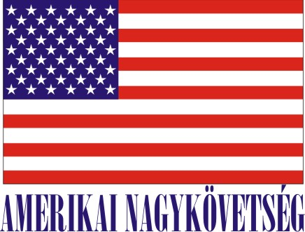
American Embassy Budapest
is seeking a highly motivated student for a
Local Internship
(unpaid internship)
in the Human Resources Office in the Spring 2020

- Duration:
20 hours per week (variable hours) for approximately 3 months.

- Major duties and/or projects, the scope of work and related duties:
- Collecting labor, social security, visa, recruitment information from the “leader” info websites (origo, index etc)
- Researching governmental websites to confirm the collected information.
- Preparing summaries of the announced and planned changes.
- Assisting in drafting and translating documents.
- Researching possible advertising sources that are free of charge.
- Assisting in drafting vacancy announcements, advertisements.
- Preparing statistics/comparisons regarding various sources of advertising.
- Assisting in interview scheduling and enrolment.
- Assisting in different fields of HR (recruitment, social security, etc.).

- How will this internship benefit the section and the intern:
The internship program is a great opportunity for the interns to work in a professional environment together with Hungarian and American colleagues. The intern will have an opportunity to master his/her communication skills, to follow and learn the frequently changing laws, regulations and collect information and improve customer service skills. The intern can gain practical knowledge on the field of HR. The HR Office will benefit from the interns’ fresh academic knowledge, their creativity, as well as computer skills.
Certification: The Human Resources Office has the adequate workspace and equipment for the interns to perform the duties during the internship.

How you apply:
Submit your application form (obtained from your university) along with your CV, Statement of Interest, and certification of active student status to the Human Resources Office at the American Embassy, Szabadság tér 12. 1054, Budapest or to budapestrecruitment@state.gov.
Closing date: January 24, 2020.
Please note this internship is unpaid.

