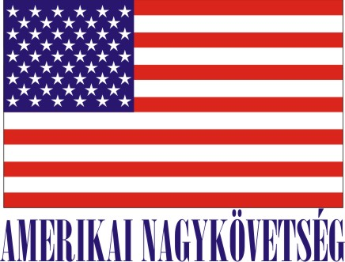
American Embassy Budapest
is seeking a highly motivated student for a
Local Internship
(unpaid internship)
in the Commercial Section for Spring-Summer 2014

- Number of hours/day:
8 hours per day for 4 months – 6 months (maximum)

- Major duties and/or projects, the scope of work and related duties:
-Assistance with preparing promotional materials, market research and briefing materials
-Assistance with commercial news summaries, briefings on meetings
-Assistance with compiling guest lists
-Collecting statistical data including information on trade and production trends etc.
- Participation at American Chamber events, professional conferences and forums
- Assistance with interpretation at business meetings
-Assistance with data entry into Commercial Services’ databases
-Assistance with trade events/trade missions/receptions

- How will this internship benefit the section and the intern:
The internship program is a great opportunity for the interns to work in a professional environment together with Hungarian and American colleagues. The intern will have an opportunity to master his/her communication skills, learn new marketing and analytical techniques, and develop planning and work organization. CS Office will benefit from the interns’ fresh academic knowledge, their creativity, as well as computer skills.

Certification: FCS has the adequate workspace and equipment for the interns to perform the duties during the internship.

TO APPLY: Please submit application form (can be obtained from the Educational Institution), CV and Statement of Interest toHuman Resources Office, American Embassy, Szabadság tér 12. 1054, Budapest, Closing date: March 22, 2014.

