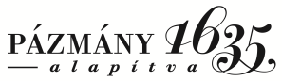 | Pázmány Péter Katolikus Egyetem  Barat Szent Magdolna Zsófia Kollégium  1088 Budapest, Múzeum utca 19.  hszk@btk.ppke.hu  Intézményi azonosító: FI79633

Request
for room changing procedure at the Barat Szent Zsófia Magdolna Kollégium

Student’s name:
Neptun code:
Number of the current room:
Number of the new room:

Reasoning:

………………………………………………………………………………………………………………………………………………………………………………………………………………………………………………………………………………………………………………………………………………………………………………………………………………………………………………………………………………………………………………………………………………………………………………………………………………………………………………………………………………………………………………………………………………………………………………………………………………………………………………………………………………………………………………………

Date.: ………………………………..

…………………………………………..
Signature of the student

