Space: Topography, Regions and Regional Identities (UK)

1. Translate into Hungarian.
The British Isles –  The United Kingdom –  The UK –  Britain -  Great Britain –  British – | Northern Ireland –  The Midlands –  East Anglia –  The (Scottish) Lowlands –  The (Scottish) Highlands –

2. Word formation. Derive the requested words from the name of the countries.
Name of country | Name of inhabitant | Adjective for people | General adjective
UK
England
Scotland
Northern Ireland

3. Match the parts of the British Isles with the adequate categories. One item may fit several categories:
England, Wales, Scotland, Northern Ireland, The Republic, Isle of Man, Channel Islands
- UK:
- GB:
- The British Isles:
- The Island of Ireland:
- Crown Dependencies:

4. Fill in the table.
 | Capital city | Population | Patron | Flower symbol | Flag
England
Wales
Scotland
Northern Ireland

Translation practice (Britain, topography)
Julian Barnes’s England, England (1998)
In the excerpted passage (cf. handout), the female protagonist Martha remembers how she would play the England jigsaw in her childhood.
(a) Find the shires on a county outline map of England and Wales. Attention: county names reflect the administrative system in the time of the protagonist’s childhood, and not the current names in 1998. Welsh counties appear in English names.
(b) Discuss the associations of the counties. How does the England jigsaw reflect the narrator’s and Martha’s mental map of England?
County map for the UK:
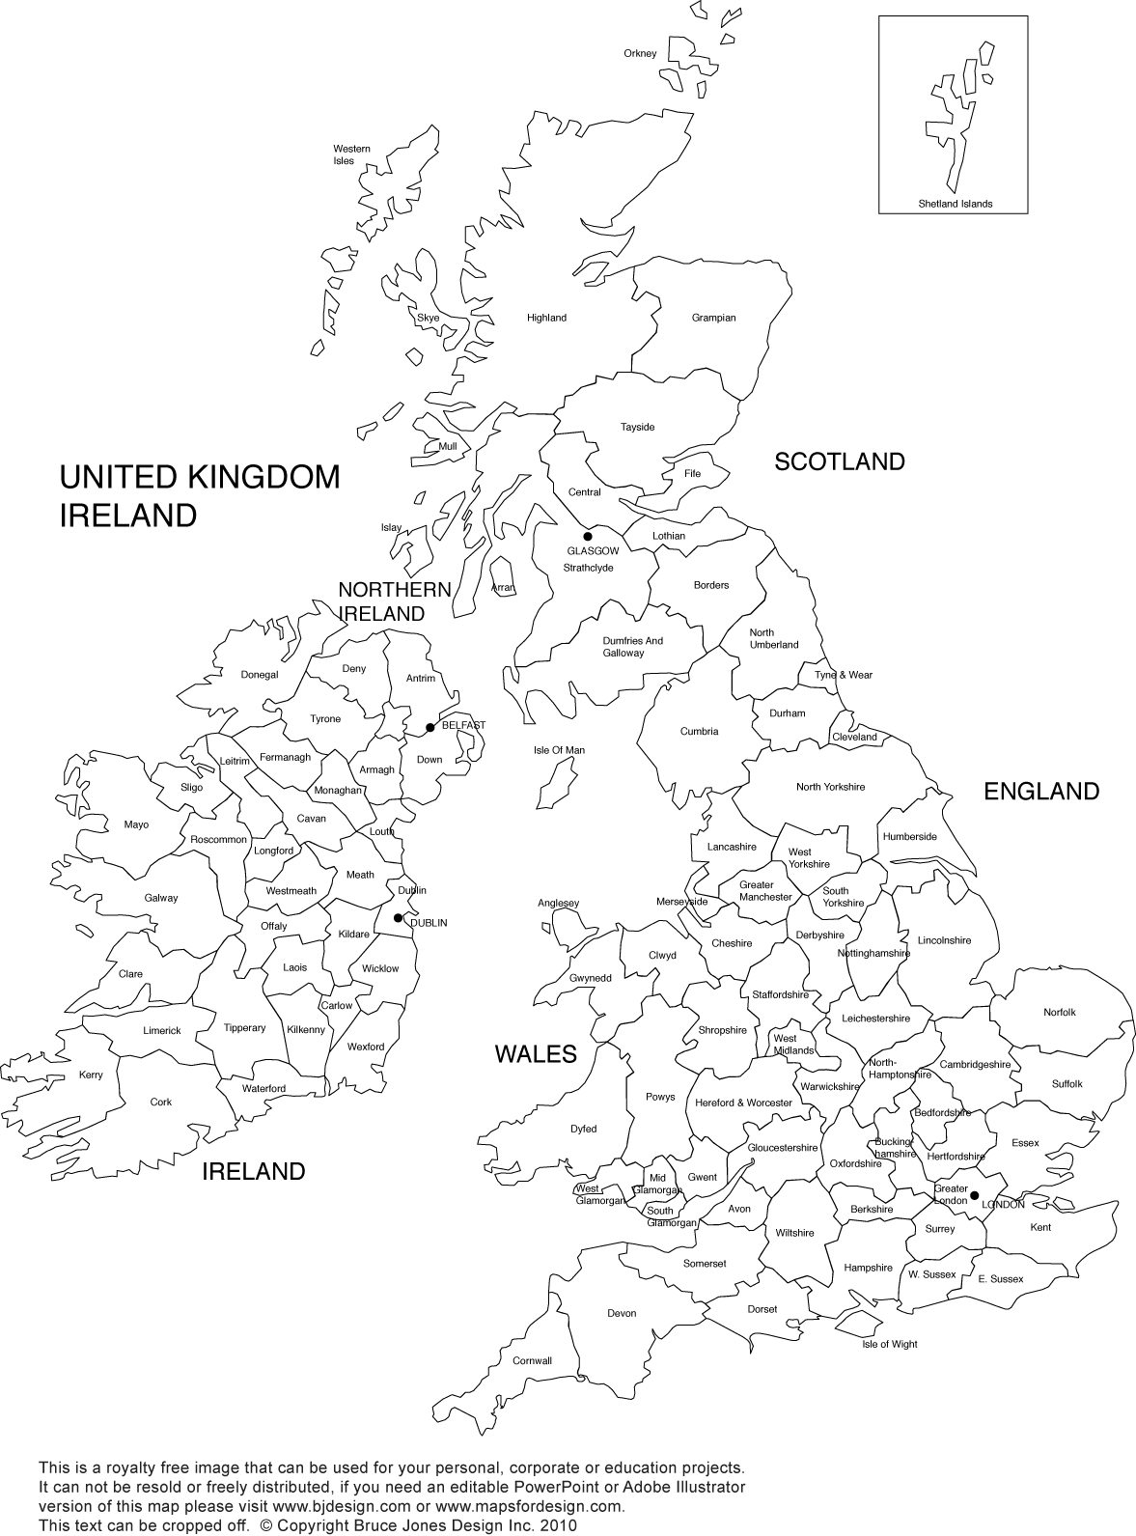
Historical counties of Wales:
