Thesis for the Doctoral Degree (PhD) Dissertation

Gyula Kosztyó

The History of Transcarpathia as the North-eastern Operational Territory
(1944)

Pázmany Péter Catholic University
Faculty of Humanities and Social Sciences
Doctoral School of History
Workshop of Economy, Regional and Political History

Supervisor: József Botlik PhD

2021
- Preliminaries of the Research, Raising a Problem

Due to its geographical location the territory of Transcarpathia played a significant role in the military and strategic notions of both Germany and the Soviet Union. For the Germans it meant a transportation route, while in the Soviet concepts, the obtainment of the territory would open the possibility to issue forth towards the Hungarian Great Plain.
The Red Army had been leading an ongoing attack against the German Southern Army Group since December 1943. Having crossed the Dnipro up till February 1944 the Ukrainian Fronts during five larger military operations were able to cause significant losses to the German opponent in defense. As a result of the attack, they managed to occupy the whole territory of Right Bank Ukraine, the Crimea, Moldova, they even reached the foothills of the Carpathians as well as the borders of Romania. With this advance of the Soviets, the German battle-front was actually torn apart in the South, as a consequence of which there appeared a 150-200 km split between German army groups “A” and “South”. The Germans did not have the potential to fill in the breach caused by the adversary.
Amidst such front events Hungary was occupied by the German troops on 19 March 1944. The occupation of the country could happen due to a number of reasons. As a consequence of the Soviet breakthrough in Galicia there was a need for the Hungarian military force, transportation routes leading through Hungary had to be provided. Commissioning a government loyal to the German leadership, reducing the possibility of a call-off attempt similar to the Italian one to zero percent, a solution for the “Jewish problem” – all served as reasons for justifying the occupation of Hungary.
Whilst German soldiers were occupying Hungary, the Soviet troops reached the historical Hungarian border, the heartland of which was Transcarpathia.
The subject of my theses is the history of Transcarpathia during the period of 19 March – 27 October 1944. In this period, namely from 1 April 1944, this territory is referred to as the North-eastern Operational Territory following a parliamentary ruling on the matter.
I set two main goals in my research. The first – to present the event- and political history of the seven months focusing on the operational administration formed in the region. Meanwhile I aim to analyze the correlations and correspondence of political and ordinary life.
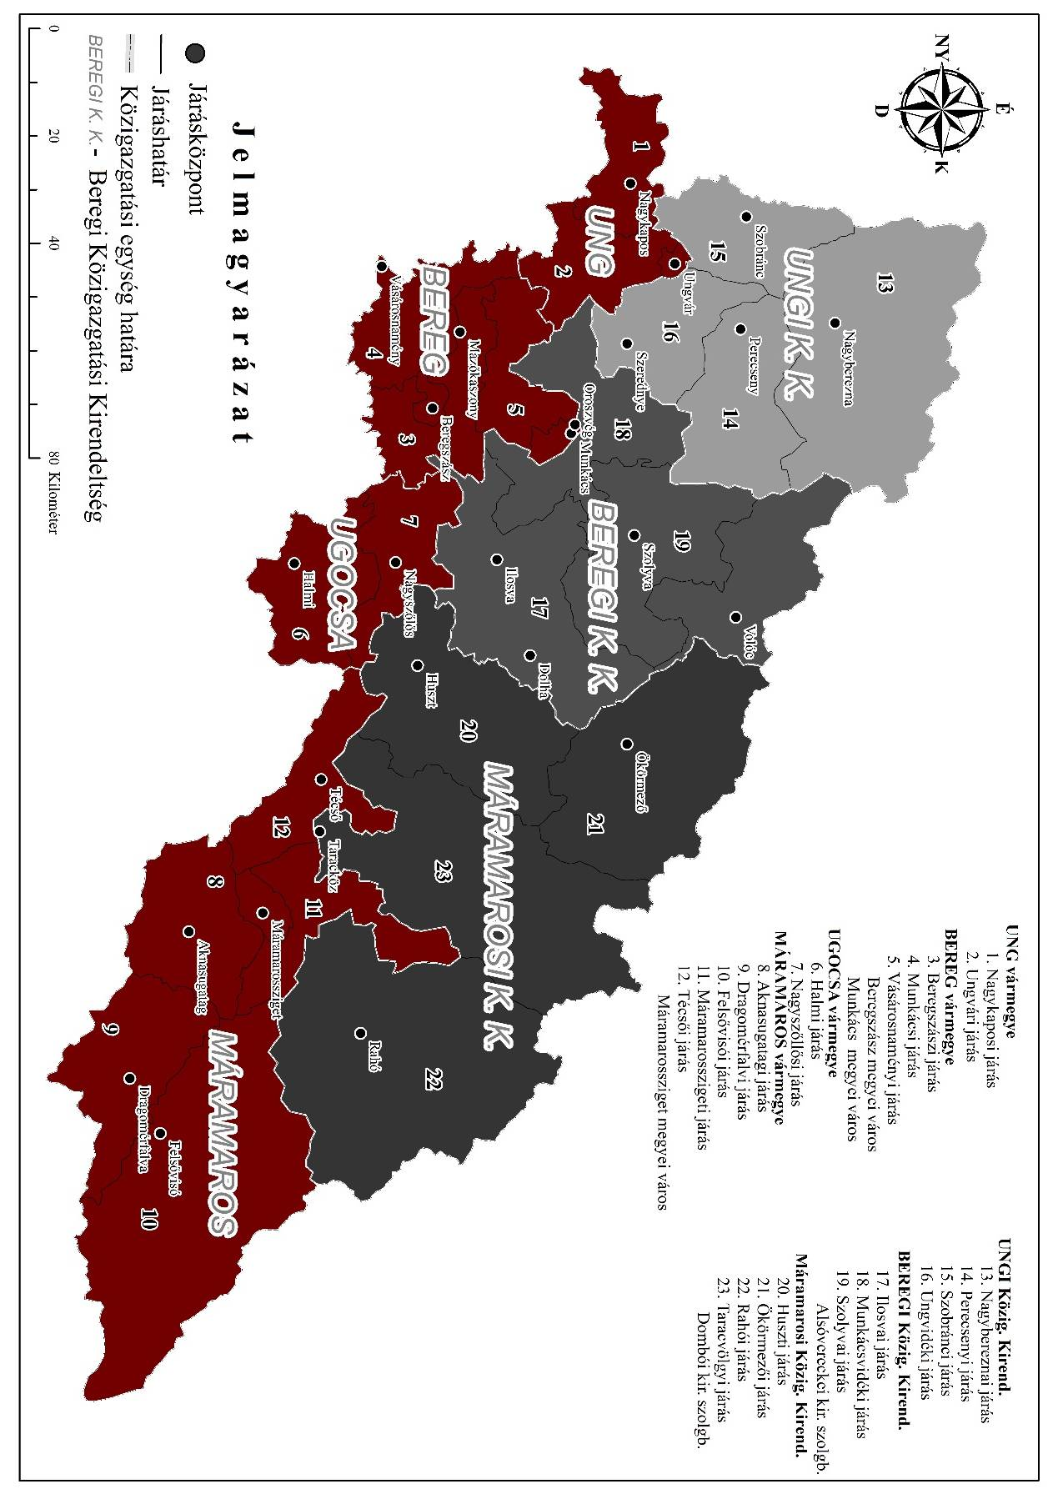
The Administrative Extension of the North-eastern Operational Territory in 1944

The clarification of certain crucial issues was one of my goals. I was especially interested in the correlations, the operation and problem solving abilities of the civil and the military administration existing simultaneously. My main objective was, however, to provide answers to certain questions - whether the local political leadership changed as a consequence of the German occupation. If the answer is “yes”, on what administrative levels did it cause alterations, who were the individuals it concerned? If changes of individuals during the German occupation in Transcarpathia really occurred, then the next important question arising is how was the new administrative staff different from the previous individuals?
I have also examined the opinion of the local Hungarian administration concerning the outcome of the war, whether they were hopeful or pessimistic in 1944. I was also interested in the point of view of different political parties concerning the social status of the local population, or on the fact of the Red Army reaching the historical borders. As the 1944 appearance of the communist movement in Transcarpathia was not unprecedented, my aim was also to clarify the viewpoints of the local conservative- as well as the radical political elite concerning the activity of certain Soviet partisans whose frequent appearances in the territory had already been recognized. Among my goals was to explore the impact of the illegal organization activity performed by Soviet partisans among the mainly Slavic population.
Within the thesis my main objectives were the following:
- to provide a clear picture of administrative and political changes taking place in Transcarpathia in the period of 1920-1944.
- to present the background of Transcarpathia’s classification as a military operational territory in 1944
- to describe quality alterations the creation of the North-eastern Operational Territory caused within the local administration
- to discuss political effects of Hungary’s German annexation in Transcarpathia
- to provide additional information never published before concerning the tragedy of the Jewish population of Transcarpathia in 1944, focusing mainly on the consequences.
- to examine whether the presence of military forces, air raids and operational vacating had serious effects on the local population
- to picture the circumstances under which the Hungarian administration of Transcarpathia ceased to exist in the fall on 1944
- to put to account as many sources as possible available in the Berehovo Department of the Regional State Archive (of Ukraine) in order to widen our knowledge of the history of Transcarpathia
Within my analysis my main intention was to apply available sources that had not been the object of scientific research before.

- The Structure of the Dissertation. Literature and Sources Applied During the Research

A significant part of Transcarpathia (as well as all Eastern Europe) was already a heartland bordering the frontline of the Soviet Red Army by 1944. The administrative-, political- as well as the event history of the above mentioned heartland is presented in seven chapters of my work.
In the first, broader chapter, preceding the presentation of the substantive part of the research, my main goal was to provide a general picture of the main administrative, political and economic alterations happening in Transcarpathia in the period of October 1918 – October 1944. I considered this introduction significant in order to examine the events of the year 1944 within historical continuity and context.
The second, briefer chapter is focused on Hungary, namely the main alterations of the country’s internal and foreign policy during the period between the fateful year of World War II – 1943, up till the date of 19 March 1944. Geopolitical modifications evolving from the military situation are briefly presented as well.
In the third chapter I analyzed alterations within the operation of counties and administrative sub-offices, those that appeared due to the formation of the North-eastern Operational Territory. The aim was to present modifications occurring due to the requalification as an operational territory, with institutions responsible for issuing decrees as well as those performing executive duties within the administration.
The following chapter is dedicated to the political life of the North-eastern Operational Territory. In its introduction the political life of Transcarpathia as a territory reannexed to Hungary in the years of 1938, 1939 is presented in detail. The main emphasis is put on the organization of political parties from the year 1939, the strivings of Rusin national parties, the autonomy intended to be provided for the Rusins and the illegal communist movement. A brief subchapter follows comprising the discussion of the effects of the German occupation on the Hungarian leadership, the change of the government. A prudent analysis of alterations within the local political life closes the chapter. The activity of local parties in 1944 is described in detail, the characteristics and alterations of their operation and ambitions before and after 19 March 1944. A significant aim was to dedicate a subchapter to the illegal communist organization in the given territory operating with mixed success from the year 1938. In connection with this movement I describe the preliminaries as well as the regulations the Hungarian administration introduced following the German occupation in order to render impossible the activity of Soviet partisans landing with parachutes.
The fifth chapter concentrates on the history of the Transcarpathian Jewish population, the circumstances of their collection and deportation in 1944, I give a brief analysis of their fate in the North-eastern Operational Territory. The chapter - divided into subchapters - discusses the events the Israelite population was subject to from the moment of the German occupation of the country, up to the collection of all Jews. I considered it to be crucial to devote a separate subchapter to the immediate consequences of the deportation of the Jewish population.
My original goal with the sixth chapter was to outline the climate of opinion of local Hungarians as well as the representatives of other nationalities in Transcarpathia in 1944. However, in the midst of my research, the processing of the literature, I had to realize the unaccomplishable nature of my intention, since, still true referring to current societies, the demonstration of public opinion is not an easily realizable task. To be able to revive a genuine picture, numerous data would be necessary, unfortunately we face a shortage of sources (recollections mainly), in addition, there are no basic researches of social history of this era. Thus, I had to rearrange the objectives of the unit in the given phase of the research. Instead of the extremely difficult demonstration of a public opinion, I chose to examine social phenomena appearing in 1944, those that could definitely influence the general atmosphere among the local population. Such topics examined are air raids or the growing military presence.
In the last chapter of my dissertation I focus on the last days of the Hungarian administration. The period which encompasses ordinary life just before the Soviet military occupation was fully formed and the Hungarian administration was forced to file out.
My work does not include the discussion of topics like the economic life of the North-eastern Operational Territory, it does not deal with the changes of economy in process in 1944. Nor does it discuss public provision, or the complicated procedure of the surrender of goods. The inclusion of these topics would go beyond the volume limits of my work.

*

The subject of my research is not among extensively studied and analyzed ones. Publications that have to some extent included the history of the North-eastern Operational Territory contain only superficial pieces of information. Randolph L. Braham, the American researcher of the Holocaust was among the first to deal with the topic. In his view the goal of forming military administration in Transcarpathia in 1944 was to solve “the Jewish question”. Among the Hungarian historians touching the topic is Csilla Fedinec, who merely mentions the fact of the introduction of special regulations in administration in 1944 in accordance with a decree issued by the prime minister. József Botlik’s publication of 2005 follows, he dedicates a separate subchapter to the North-eastern Operational Territory, mainly analyzing the process of vacating. The work of László Brenzovics is published in 2010, he only mentions the existence of a military administration in Transcarpathia in 1944. The Ukrainian historiography has not dealt with this period extensively, not at all with the military administration of this era. It has to be mentioned that the sources available are mainly written in Hungarian language, which may be an obstacle for Ukrainian historians.
My doctoral dissertation presents the political and social history of the North-eastern Operational Territory in 1944 applying numerous yet unrevealed sources. The sources of research were collected by me in five archives of Hungary and one in Ukraine.
I have conducted a research at the National Archives of Hungary analysing files of contemporary Hungarian ministries referring to Transcarpathia. I mainly concentrated my work on fonds containing presidential (K 149) and general (K 150) official copies of the Ministry of Internal Affairs, as well as documents of the Minority Department of the Prime Minister’s Office (K 28). During my analysis of documents I also researched the collection of documents remained from the office of the Government Commissioner of Transcarpathia (K 774).
At the Budapest City Archives I mainly examined the materials of criminal suits (VII. 18. d.), while at the Archives of the Institute of Political History I concentrated on the fonds related to the operation of communist partisans of Hungarian origin (Fond 501., Fond 682.). In the Ráday Archives of Budapest I researched the recollections of Aladár Vozáry, a Transcarpathian politician and journalist based in Munkács (now Mukachevo). (Fond C. 150.)
At the Hungarian Military History Archives I analyzed documents referring to military corps that marched across and were cantoned in the North-eastern Operational Territory in 1944. I have also applied in my work collections of studies and recollections kept at this institution, as well as documents once belonging to the Hungarian Royal General Staff and its chief.
The collection of sources in the archives of Hungary comprised a smaller part of my research. The most significant part of the documents was collected at the Berehovo Department of the Transcarpathian Regional State Archives in Berehovo, Ukraine. In this institution I focused on the documents of contemporary local Hungarian administration, in most cases those belonging to the highest level branch of county administration – offices of the Lord lieutenant and the deputy-lieutenant. Of the four historical Hungarian counties I mainly concentrated on documents of such matter issued in Ung and Ugocsa counties. Unfortunately, due to the destruction of documents, original documents of offices of the Lord lieutenant and the deputy-lieutenant in Máramaros county are unpreserved, while the research of such evidences of Bereg county is currently and for an indefinite period impossible. In those regions where documents of the above mentioned institutions were unpreserved, I examined the available files of district high sheriffs as well as those of notary offices.
The procession of contemporary documents of county administration refers only to the flatland area of the North-eastern Operational Territory. Documents concerning mountainous areas mainly populated by other nationalities have not been examined by me. Of all the contemporary documents belonging to three official institutions of mountainous areas between 1939-1944, only those of two, the Ung- and the Máramaros Administrative Sub-office remained in an acceptable state. The Bereg Administrative Sub-office is an exception though, the documents of this office remained in quite a fractional state.
In order to handle documents produced by contemporary administration with source criticism, during my collection of archive documents, I paid a special attention to citizens’ complaints, correspondences, both official and private. Again with regard to source criticism, I have studied all press products published in Transcarpathia at the time. All thatwere published in the operational territory in 1944.

- The Methodology of the Research

In order to achieve objectives set I conducted both librarial and archival research.
During my librarial research I studied all the scientific works that had been published on the topic. Having gained the necessary knowledge existing, I began the exploration of archive sources.
Amid my archival research I worked with sources untouched, unstudied before. The exploration, photo shooting, systematization and processing into source record lists of the huge amount of documents did require energy. As the documents collected are of different type concerning their formation – documents of various ministries for instance, those of military bodies, of civil administration, recollections, civil letters etc. – source criticism was already inevitable due to the diversity of document types. Nevertheless, my intention was to apply source criticism in all possible ways I could, that is why I have processed all available contemporary press products of the given era. A contrastive procession of information followed, taking into consideration press products as well as documents produced by the administration.
By composing the dissertation I aimed to prepare a study of event- and political history, which could as well add information to the social history of the given geographical region. The survived recollection by Aladár Vozáry was of a great help to me in this matter. The author, being a witness to the events, recorded his own experiences in Munkács (now Mukachevo) in the period following the German occupation. He gives us a detailed picture of contemporary circumstances from the perspective of everyday life including the lack of grease, the military tumult, the frantic withdrawal, the rigid reality of the tragedy of the Jewish population. Whilst Vozáry merely gives a short note to the symptoms of the crisis in 1944 (political radicalization, a lack of grease, the appearance of partisans etc.), my goal has been to highlight the causes of these phenomena in my work, thus supplementing Vozáry’s recollection. Vozáry could not have an insight into the administrative documents by that time – since he was already on the political periphery – through which we are able to reconstruct the answers the Hungarian administration gave to these issues to manage the crisis. The above mentioned recollection, as well as the citizens’ complaints, provided an opportunity to contrast the everyday experiences of local citizens with the opinion of government bodies, ministries and the local administration, and draw my own conclusions based on all the information gained.
Overall I can state that with the application of proper source criticism, I managed to achieve the objectives set in the beginning of my research, that is to process the sources professionally, as well as to compose a work containing new research results.

- Research Results

The only pieces of information available prior to the given dissertation with regard to the North-eastern Operational Territory were the time of its creation: the beginning of April 1944, and the fact that retired military leaders were appointed to the most important positions in the territory. Due to the given work, we have expanded our knowledge of the history of the given era.
The German occupation caused serious consequences on the political life of the North-eastern Operational Territory. First of all, the system of administration had to be transformed in order to serve German goals in the direct heartland of the front. New leaders were appointed in Transcarpathia based on political aspects. The alterations affected the positions of all Lord lieutenants and deputy lieutenants in the four counties. During the personal changes the Party of Hungarian Life lost their political positions, their posts were overtaken by the Hungarian National Socialist Party. Along with the switch of parties, extremist or anti-Semite individuals were appointed to responsible positions, the activity of whom had been successfully rendered impossible by conservative members of the Party of Hungarian Life prior to that. It is apparent that without the German occupation neither radical movements, nor extremist far-right parties would have been able to create their political organizations.
It was also due to the military occupation that the German authorities had the chance to eliminate the activity of Soviet partisans in Transcarpathia, they actually supervised the whole process. It was one of the most significant aims for the Germans to deactivate partisans arriving from the Soviet Union, since they were the scouts of the Soviets, and in addition, they were endangering military transportations of the Germans. Therefore the elimination of Soviet partisans was strictly monitored, that is the regulations of Hungarian authorities which were in fact successful until the fall of 1944. Although Soviet guerrillas had been hiding in the Carpathian forests since the summer or 1944, the local Hungarian administration and political leadership (for ideological reasons mainly, as well as because of the violent measures taken by communists in 1919 still within living memory) did not make contact with the enemy. There was only one exception from the rule – András Bródy, a Rusin politician, for a short period prime minister of Podkarpatska Rus. Bródy, through go-betweens, got in touch with Tkanko, one of the partisan leaders, soon it turned out however that he was trusted neither by the partisans in Transcarpathia, nor by their the supreme leadership. Later, in 1949, Bródy was tortured by the Soviet authorities, the court sentenced him to death based on fabricated accusation, in the end he was executed.
It can also be stated that the German occupation of Hungary played a significant role in the “solution of the Jewish question”. Partly due to the deportation of the Jewish population, as well as the circumstances of war, the local society of Transcarpathia had to face constant challenges. As the territory actually became a heartland, the military presence was taking on ever larger dimensions, which caused congestion and tensions between civilians and soldiers. The Hungarian administration did everything in their power to ease the crisis, their measures however, proved to be insufficient. The ever growing scale of transportation difficulties, the shortage of goods, the more powerful attacks of Soviet partisans from October 1944 as well as the destructive air raids – all diminished the power of the Hungarian administration.
Meanwhile, on 2 October 1944, the Red Army occupied the first Transcarpathian settlement, the village of Verebes in the Volóc district. Following the takeover of power by the Arrow Cross Party on October 15, the contact of the territory with Budapest was declining. András Vincze conducted his last session as a government commissioner in Ungvár (now Uzhgorod) on October 19, then he moved his office to Ózd on October 23. With this act of his, the office of Government Commissioner of Transcarpathia ceased to operate. The Hungarian administration of flatland counties of Ung, Bereg, Ugocsa and Máramaros created in December 1938 were liquidated by the occupant Soviet military administration during October-November 1944.

- Acknowledgements

I would like to express my gratitude to a number of people. First of all, I am grateful to József Botlik, my supervisor, who contributed to the present work by advising me and providing sources of research. I would also like to thank the archivists of different cities, namely Ilona Kutassy, director of the Berehovo Department of the Regional State Archive, Mária Jeremkina, head of department of document preservation, archivists Larissza Létay and Ljuba Szkazova.

- Publications on the topic

- Kosztyó Gyula: Megszállás, terror, elhurcolás. Szovjet berendezkedés Kárpátalján (1944–1950). Géczi Róbert (szerk.): Az Elbától Vorkutáig. Magyarok és magyarországi németek szovjet hadifogságban, kényszermunkán a Gulág-on. Budapest, Magyar Napló – Veritas Történelemkutató Intézet, 2017. 161–173.
- Kosztyó Gyula: Az Uszta-Priscsepa partizánosztag tevékenysége Kárpátalján (1944. augusztus 8. – október 26.) Dupka György – Zubánics László (szerk.): A Kárpát-medencében elhurcolt magyar és német rabok nyomában Oroszföldön és a Kaukázus országaiban. Budapest–Ungvár, Intermix Kiadó, 2017. 127–153.
- Kosztyó Gyula: „… ne felejtsék el, hogy saját terület és saját állampolgáraink lakják.” Az Északkeleti Hadműveleti Terület 1944-ben. Hajdú Anikó (szerk.): Multietnikus világok Közép-Európában, 1867–1944. Nyitra, Téka Társulat, 2016. 165–176.
- Kosztyó Gyula: Az ungvári zsidóság a vészkorszakban: gettósítás, deportálás és a zsidó vagyon sorsa 1944-ben. Betekintő, 2016. 4. sz. 1–32.
- Kosztyó Gyula: Közállapotok Ungváron a háború árnyékában (1944). Pro Minoritate, 2015. 1. sz. 131–158.
- Kosztyó Gyula: Irreguláris szovjet katonai egységek Kárpátalján. A Rákóczi-partizánosztag működése Kárpátalján a magyar rendvédelmi szervek iratainak tükrében. Ekert Mária – Molnár Attila (szerk.): Teremtés, politika és művészet. Budapest, NKE – Molnár Tamás Kutató Központ, 2015. 365–379.
- Kosztyó Gyula: Iskolán kívüli népművelés Kárpátalján 1940–1944 között. Ungvár, KMMI, 2014. 1–43.
- Kosztyó Gyula: Az Ungvári Kémelhárító Osztály jelentései Kárpátaljáról, 1939–1944. Scientia Denique, 2011. 1. sz. 28–37.

Braham, Randolph L.: A magyar holocaust. Gondolat Kiadó, Budapest. 1990. 108. p.
Fedinec Csilla: A kárpátaljai magyarság történeti kronológiája 1918–1945. Lilium-Aurum, Dunaszerdahely. 2002. 619. p.
Botlik József: Közigazgatás és nemzetiségi politika Kárpátalján II. A Magyarországhoz történt visszatérés után 1939–1945. Nyíregyházi Főiskola, Nyíregyháza. 2005. 197–247. p.
Brenzovics László: Nemzetiségi politika a visszacsatolt Kárpátalján 1939–1944. Kárpátaljai Magyar Kulturális Szövetség, Ungvár. 2010.

