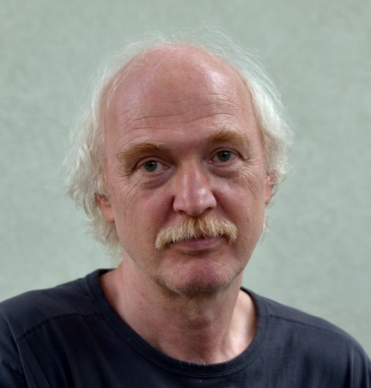
Zoltán Halasi
poet, writer, literary translator

“Literary translation is a great opportunity to satisfy one’s hunger for knowledge.”

Photo: Szilágyi Lenke

In his childhood Zoltán Halasi began learning German and Russian and spent much time in German speaking areas, hosted by native families. During his trips, by his own account, he acquired language skills. He received his degree from the University of Szeged where he majored in History and Hungarian Literature and Grammar. During his university years his attention was already drawn to proofreading, and he also translated prose and poetry. At that time his own writings ended up in his drawer because he was not satisfied with them. In those days the personal aspect of writing gave him a hard time, so he was rather engaged in literary translation. As an ambitious person, he began translating the works of Rilke and Kafka. The works of these authors provided him an opportunity to escape intellectually from the materialist world of the socialist era. He took these translations to Európa Publishers where Szabolcs Várady, a former editor, read them and liked them. Zoltán Halasi soon became an appreciated literary translator of the Publishers’. In those years he put a selection together from the aphorisms of Kafka, which was published in Hungarian entitled Az én cellám – az én váram (My Cell – My Castle). Ever since, he has translated works of such highly acclaimed writers and poets as Johann Wolfgang von Goethe, Carl Gustav Jung, Johann Peter Hebel, Elias Canetti or Elfriede Jelinek. His own writings were awarded the József Attila Prize and the Füst Milán Prize just to name but a few.
In addition to German, Zoltán Halasi also translates from Russian, Polish, Lithuanian and Persian among other languages. In case of the latter two he used rough translations which were done by two of his good friends, Endre Bojtár and Róbert Simon who also added cultural explanations to the translations. For some time he needed help with Polish and Russian translations, but after a while he could do them on his own.
Zoltán Halasi regards literary translation as a passion. According to him quality literature is filled with cultural references that are worth taking notice of in order to be able to create a good translation. For instance, when he was translating one of Canetti’s works for the second time, he finally appreciated the author’ message and the purpose of it. He also understood the connection between the author and his characters. This was the first time that during translation Halasi felt that the author was standing behind him dictating. However, in order to hear this so-called inner voice one has to know the author inside out: what they love and hate. In other words one has to put oneself in the author’s shoes which goes hand in hand with a lot of research and reading. For example, he said that Elfiriede Jelinek’s Téli utazás (Winter Journey) is brilliant linguistically speaking, but really hard to understand and it helped him a lot during translation that he spent some time in Germany (with a translator scholarship).
After the political transformation of 1989 it was becoming increasingly difficult for translators to choose books for translation. If an author did not belong to the best-selling ones on the book market, it was difficult to find publishers for the book. However, thanks to his stubborn nature Zoltán Halasi did not give up and from the beginning of the 1990s he has mostly been translating works that are close to his heart and chosen by him, despite it still not being easy these days. For a good while, however, he has been more engaged in his own writings than literary translation. In the past few years Elfriede Jelinek has become his favourite author and nowadays he is considered to be her Hungarian voice.
Zoltán Halasi is one of the founders of the Hungarian Literary Translators’ Association that was established in 2003. He started to think about the foundation of such an association for two reasons. One reason was that he received foreign financial aid for a translation, but the publishers wanted a considerable amount from that money. The other reason was the royalty for poetry translation having not changed in ten years. Therefore, he decided to put a questionnaire together and give it to his colleagues. Forty-five literary translators filled them out and from the answers it could be seen how royalties had changed over the last 40 years, and whether it was possible to do literary translation for a living. The result showed that there was an urgent need to protect the interests of the translators. At the same time he started a series of events entitled Metafora estek (Metaphor evenings). During these events famous literary translators were talking about translation, what they liked about it, what challenged them the most and how they ended up in this profession. The aim of these events was to make literary translators (more) visible.
Nowadays he is also working, for example, at Pázmány Péter Catholic University as a teacher of literary translation. In an interview he once said that the Hungarian translation of E. T. A. Hoffmann’s The Life and Opinion of the Tomcat Murr should be taught to every student of literary translation. The translator, Ede Szabó had already had many years of experience behind him when he translated it, therefore, he knew the nuances of the source language very well and he managed to make them harmonize with the same nuances of the Hungarian language. In Zoltán Halasi’s point of view this is real literary translation but this professional knowledge can only be obtained through hard work, a good deal of translation and lots and lots of practice.

Web page: http://www.halasizoltan.hu/hu/

