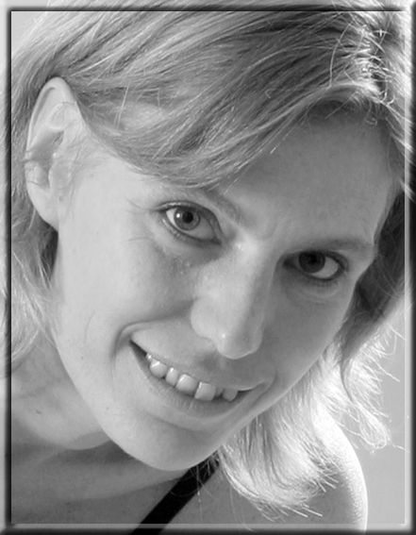
Ágnes Székely
translator, interpreter, teacher, ski instructor and mother

“Translation is too complicated to have a motto…”
Working languages:
Hungarian - mother tongue
English - fluent
German – passive

Ágnes Székely is currently working as a freelance translator, but she also worked as an interpreter and an English teacher. She is a ski instructor and a mother of three young boys, too. She translated several books including Home Truth by Freya North and Tuesday the Rabbi Saw Red written by Harry Kemelman, Buddhism for Mothers by Sarah Napthali, How Relationships Drive Creativity by Joshua Wolf Shenk, and she is currently translating the book of Roman Krznaric entitled Epathy. She also translated films like Finding Nemo, Strangers on a Train, Matrix, Deep Impact or The Bodyguard – just to mention a few.
The beginning - a colourful personality:
She always loved to write but soon she realized she didn’t want to become a writer, but rather a translator. For her, doing literary translation is a kind of compromise, as she can write without becoming a writer. She likes that she can put her own words down even if she just translates other writers’ works and that she contributes to these books. It has all started in grammar school, where several competitions were organized for students, and one of them was a translation competition. This was when her journey as a translator began. At university, where she studied to become an English teacher, she was lucky to have great teachers and she also received a lot of recommendations. Enthusiastic, she wanted to find a job when she left school, but against all odds, she could not find any. It was the luck of the draw that she met a friend one day, who happened to be looking for a translator to translate a new film. She loved her job as she could be creative, but she also accepted offers to do technical translations as they are better paid. While working, she attended college to become a ski instructor - she hates cold weather and she could imagine herself doing translations in a beautiful ski resort during long winters. However by the time she graduated, she was already pregnant with her first son. She always wanted to have a big family, today she is happily married with three children.
Film translation:
According to her it is easier to translate a film than a book, but it also has its challenges. For example, once she had to translate a documentary film for Discovery Channel, and although they sent her the script, they left out the name of an exotic fish so she spent half a day trying to find out its name. At some point she thought to herself that she would just leave it out, but again, there was this fish on the screen that the spectator would see but wouldn’t be able to name it. Often, when making subtitles for films, they send her the statistics about the target audience and how many characters they are able to read in a given time, so she knows how long the translated sentences can be. She was often given the time the subtitle would be shown to help her work. If the audience won’t be able to read the subtitles then there is no point in translating it. Also, when she translated Hungarian films into English like My Guide (Újratervezés), she had to bear in mind that the language she uses must be understood not only by native, but foreign speakers of English, too.
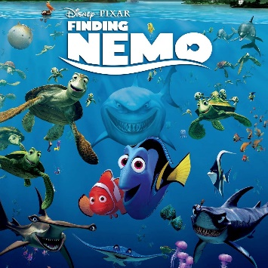
In the majority of the cases, translators are not allowed to translate the titles of the films themselves. It is rather the task of some PR managers as they know it better what will be catchy. However, when it comes to translating humour, the translator is free to come up with something funny. She mentioned the example of Finding Nemo, in which there were lots of puns she had to translate and even the names of ships were some kind of linguistic jokes. She was asking her family first, then her friends, and in the end even the neighbours about their idea on how to translate certain jokes or puns. “Say something funny, but it has to be three characters long.” One can hear that today’s Hungarian dubbing is becoming worse and worse. What is wrong with our dubbing? Mainly the lack of money and time producers are willing to spend on translation and recording. Back in the good old days there were standards: producers provided scripts of good quality and expected to receive quality translations in return. Today nearly everything is automatized. Ági mentions a case when she happily accepted an offer to translate a film, then she learned she was expected to run the script through a translation software and only correct obvious mistakes. She turned down this ‘excellent’ offer.
An ideal profession for women?
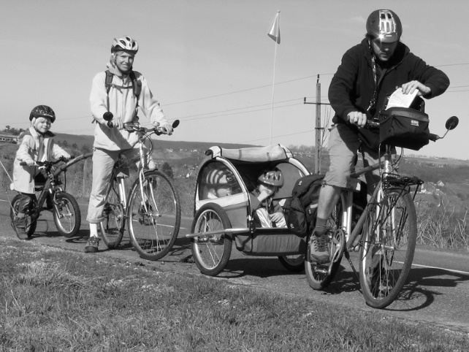
There is a link between translating and raising children: if you do it right, no one will appreciate it. No one will see how much work you put into it, but at the same time, both require hard work and are time-consuming. If you are a good mother it remains invisible, unless your children do something bad. It is the same with translating: if it is well-written than nobody will notice that they are in fact reading or hearing a translation, thus you make yourself invisible by doing your job well. Not to mention that “both ‘professions’ are underpaid”. When her oldest son was born, everything went smooth: he slept for three hours straight so she could work. She admitted that she believed that this was going to work like that, raising children was not so difficult after all. But then her second son was born, who was quite the opposite of his brother. This was when she realized she couldn’t have been further from the truth: “When you try to do your work there is just one problem: your family makes noises.” You cannot expect your three children to stay quiet all the time, or yourself to do quality work while you cannot concentrate. Otherwise she loves her work as she can stay home with her sons, even if she’s not sitting next to them she knows that if they want something she is right there and that she can make sure that they are safe at home. Of course translation also means flexible working hours but then again, you still have deadlines whether you have children or not.
Advice for greenhorns:
You need to have a talent for writing. Apart from expanding your vocabulary and reading a lot, you have to be able to recognize and adapt to different styles. You need to imagine yourself in the place of the character who is speaking. In order to do so, it is important to know the different styles in your source language so you know what is deviating from the norm or what is normal but may sound strange for you. It is not true that if you translate from English into Hungarian, knowing Hungarian is the most important: it is essential that you recognize the different styles, otherwise you won’t be able to reflect the given character. You must be familiar with your source culture. Whether you are thinking about becoming a translator or an interpreter you must have empathy: the ability to imagine the speaker’s situation, feelings and intentions, to see the world from their perspective. Don’t translate single words. Translate what you would say in their place. Also, you have to bear in mind that translating is a lonely profession, not to mention that its social appreciation is really low. You will need to surround yourself with people who value your work or find a way to ensure yourself that what you do is valuable.

You can find her on her website: http://filmforditas.blogspot.hu/
Some examples of her work:
https://vimeo.com/65288793 (My Guide by Barnabás Tóth)
https://vimeo.com/84394916 (Minimal by Márton Szirmai)

