Ottilia Boross
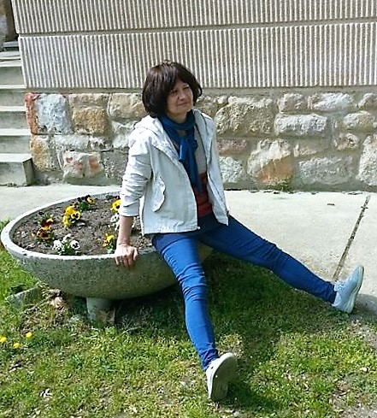
Ottilia Boros was born in 1951 in Székesfehérvár, and now she lives in Budakeszi. She is one of the best-known Hungarian psychologists, who also deals with translation and teaching. She is the associate professor at the Department of Personality Psychology at the Pázmány Péter Catholic University, as well as a lecturer at McDaniel College Budapest teaching courses on contemporary psychology in English. She started her studies at ELTE in English and geography teacher education, then enrolled for Psychology at ELTE in 1978, which she has successfully completed in 1984. She has also participated in different trainings like psychodrama, courses on autogenic training and mediation.

She has been working as an associate professor at the Department of Personality Psychology at the Pázmány Péter Catholic University since 1997 and as a lecturer at McDaniel College Budapest since 1998. In 2007 she organized and launched a postgraduate program in Mediation at Pázmány Péter Catholic University. She is a member of the Hungarian Psychological Association. She has contributed to the development of Hungarian psychology with her teaching and scientific work.

She spent a lot of time abroad due to her scholarships. She spent a month in Yugoslavia in 1988, and then she taught in June and July of 1988 in Philadelphia, USA, and at Nagpur University in India in May of 2013. She also participated in plenty of conferences held abroad, for example in Slovenia, USA, India, and Slovakia.
She has already started to translate during her university studies. She usually translates psychology related texts from English into Hungarian. Her first translation, Perceptuális képzelet was finished in 1983. She wrote one of her most memorable work, Élet az óceánban in 1992. She considers this translation as one of the most interesting and challenging translations she has done so far. While she was working on this translation she realised how important smoothness is in a translation and to express the specialised words of the source text clearly for the readers of the target text. Other memorable experience were the translation of the work, És addig éltek, amíg meg nem and the translation and revision of Élni jó! by Mihály Csíkszentmihályi in the USA where she had the possibility to meet and discuss the translation with the writer himself. She revised the book titled Őstörés by Mihály Bálint and the high quality of the Hungarian text can partly be attributable to her careful revision.
One of her most significant works is the translation and editing of Pszichológia by Atkinson and Hilgard. After she had finished the translation, it made her extremely happy that this diverse and high quality book is now available for the Hungarian readers as well. She has also participated in the creation of the Pszichológiai lexicon, which not only consists at least 3000 entries but also the English equivalents of the expressions.
Besides translation, she has also some experience regarding interpreting. During her university studies she took part in a conference on the topic of yoga as a simultaneous interpreter. Nowadays, she occasionally interprets at conferences and workshops.
Her advice for the early-stage translators and interpreters is that if they can afford then they really should acquire a thorough knowledge of a different field that they are interested in.

