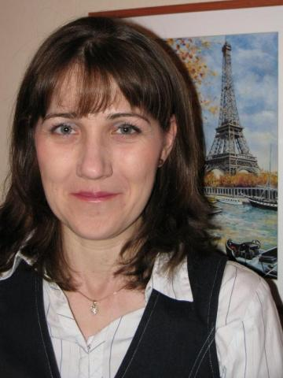
Translator and Interpreter Profile

Judit Pethő-Szirmai
Freelance interpreter and translator

Languages: Hungarian, English, French

Judit Pethő-Szirmai is a freelance simultaneous and consecutive interpreter as well as a translator. She loved languages from a very young age, and has participated in several Hungarian language competitions with great success in her school days. Judit thinks that the cultivation of our mother tongue is of foremost importance. She has honed her talents in the Sárospatak Reformed College Grammar School, where she attended a bilingual programme. She has learnt English and French, which are now her working languages. During her high school years, she took advantage of an opportunity to live and study in the United States for a year. There she lived with an American family, and also went to high school. Judit speaks about this period of her life very fondly, saying that English was almost like a second mother tongue for her.
She did French and American studies at Eötvös Loránd University. She stated that these years had a significant role in her professional development. From 1999 to 2000 she studied in Paris with an ERASMUS scholarship. She said it was a great opportunity for her because she gained more confidence in her language use, got plenty of cultural stimuli and it has aided the development of her language sense.
After graduation she decided to further her studies, now in the area of interpreting and translation. She attended the two-year-long postgraduate programme of Eötvös Loránd University, which offered courses in both consecutive and simultaneous interpreting as well as translation. Here she mentioned two of her teachers, who were particularly memorable for her. Zsuzsa Boronkay-Roe taught her simultaneous interpretation, while Zsuzsa G. Láng was mainly in charge of teaching consecutive interpreting. Both of them were a remarkable source of inspiration for Judit: they provided her with great knowledge as well as honest and constructive criticism which supported her development. She keeps in touch with most of her peers to this day, and even works together with some of them on occasions. She regularly attends professional conferences such as the annual conference of Eötvös Loránd University’s Department of Translating and Interpreting, in order to stay on top of the new trends in her profession. Because of her love of languages she also learnt Russian and Italian, and would like to brush up on her knowledge about them.
She graduated in 2005, and started working as a freelance interpreter and translator. She did several jobs even prior to getting her degree – also a lot of volunteer work – and is very thankful to a former university professor and eventual colleague of hers, who supported her throughout her professional development. Originally she was self-employed, but later in her career she started a translation and interpreting company called Prima Lingua Kft. She is interested in several topics, and mostly undertakes jobs in the areas of humanities (arts, pedagogy), sports, biology, medicine and music. She has interpreted for huge enterprises, like Xylem, BMW, and the toy manufacturer Mattel. She thinks of this profession as very versatile. She also mentioned some of her more memorable jobs: she is regularly commissioned by the Ministry of Agriculture, and is especially proud of her long-time collaboration with the International Fair Play Committee.
As for my question about what advice she would give to new graduates, she said: “Young translators and interpreters today have a bumpier road before them than my generation because of the multitude of such educational programmes. I advise them to take every opportunity to spend some time abroad in order to broaden their perspective as well as to enhance their linguistic development. Practice and preparation are also of key importance. Crucial experience can be gained through working as a volunteer translator and interpreter, especially in the early stage of one's career. Be a maximalist, but also be ready to forgive yourself. Take the time to learn from your mistakes, but don't let them bring you down. A sense of humour should be part of every translator's and interpreter's tool kit."
I was honoured and happy to get to know Judit. The conversation with her was both educational and enjoyable.

Written by Eva Behan

