Ágnes Somló

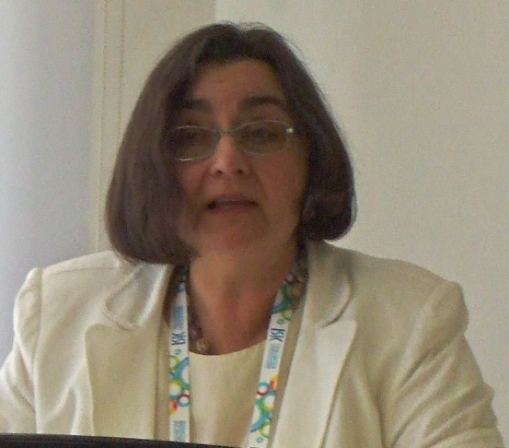
Ágnes Somló majored in English language and literature, and history at ELTE. She obtained her degree in 1980 and won the Soros-scholarship, through which she travelled to the US to study language pedagogy, linguistics and American studies. She is now a senior lecturer at the Pázmány Péter Catholic University, and teaches literature, literary translation, and translation theory. She is responsible for the existence and success of the only accredited Hungarian literary translation specialized training.

To Earn Money by Reading

Her life revolves around translation nowadays. According to her, it all began when she was a freshman at ELTE.
She always wanted to have a job where she could earn money by reading books. She loved reading and was hoping that one day it would help her make ends meet, so when her classmate told her that a well renowned literary translator, János Elbert held a translation course at the university, she agreed to attend it. Step by step, she learned the know-hows and went on to become a literary translator.
After having obtained her degree, she worked as a reviewer for a journal titled“History” (História). She also worked for the literary department of the national broadcasting organization, Radio Hungary (Magyar Rádió) in the 80’s and the 90’s, where she worked on „Writers of the modern era" (Modern írók portréi) and also translated numerous plays for the Radio Theatre (Rádiószínház), where she also performed occasionally. She is the author of two radio plays, a great number of literary and translation theory essays, and she also translated dozens of novels.

A Trip to the United States

She won the Soros scholarship and travelled to the United states in 1988. This was the first and only time when the scholarship was available for literary translators. Only four people managed to meet the criteria set by the committee, who then became top-notch translators. They were István Tótfalusi, Anna Nemes, Rita Bendes and of course, Ágnes Somló.
They were offered to take part in a six week course where they learned a great deal of useful things at the University of Pennsylvania, for which Ágnes Somló is still thankful. The programme offered specialised courses for them which she loved and according to her, the trip and the course both provided her with a whole new perspective. The only thing she never managed to get on with was baseball.

The Lecturer

She lived in Pilisvörörsvár, and offered her services to the PPCU Faculty of Humanities in Piliscsaba. She actually got a call-back from the university and started teaching translation techniques.
The following year she managed to start a literary translation course. At first there were only two of these, but then the number of courses held grew to five and the rest is history.

Her Aims

She said she wanted to transfer knowledge to her students in a way which then would benefit them throughout their lives. She lays a strong emphasis on translation theory, but does it from a praxiological point of view. Praxiology based on theory and the loveable manner she uses to teach translation techniques made her the mentor of a number of translation students who later pursued a carreer in translation. She firmly believes that one must learn the know-hows of translation as language competency in itself cannot suffice when it comes to translating a text. She also emphasizes the need to become a good critic and the need to know our mother tongues thoroughly.
(I remember we got our translations back fully revised, with words struck through and underlined, but everybody was fascinated how good our texts became after the careful revision.)

The Need for Translation Studies

Ágnes Somló saw that the literary scene degraded a great deal after the regime change. Her primary concern was to educate a new wave of literary workers, mainly translators, who would then take the stage when things would start turn to the better again.
She firmly believes that solely speaking a foreign language is not enough to make a translator. She said that translation is actually a profession, which takes long and hard work to get around tenses. She added that her perspective was hard to push through in those times, but eventually she succeeded.

Her Love Towards Africa

Just as her becoming a translator, her love towards Africa also came into existence due to her love towards books and reading. Her mentor told her that she would need to pick up some sort of special topic that she would later be dealing with.
So, when she was on a trip with her family in Vienna, she went to a book store, picked up a book about Africa, bought it, and read it. She realized how fascinating African literature and culture is, and then went on to translate many books about Africa.

Comments:

She taught many students at the PPCU Department of English and American Studies, and just about all of them became fascinated with translation and gained new insight into both Hungarian and English and of course, they obtained something that could be used to enrich the Hungarian written-word-heritage.

Tarjányi Máté
2016. 04. 28., Piliscsaba

