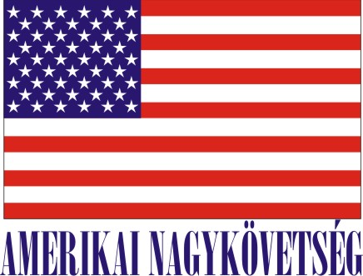
American Embassy Budapest
is seeking a highly motivated student for a
Local Internship
(unpaid)
at the American Embassy Employee Association (AEEA)

2018 Fall Semester

Duration:
16 weeks (with possible extension), variable hours

Major duties
- Assist in the preparation of tax documents and other accounting and financial tasks for the Association

- Assist with new merchandising and marketing strategies for the AEEA Diplomats’ Store promoting goods and services for the U.S. Embassy community.

- Update inventory data and assist with various duties at the AEEA Diplomats’ Store (stocking shelves, receiving products, etc.).

- Assist with events at the embassy

Benefits of the internship
The internship program is a great opportunity for the interns to work in a professional environment together with Hungarian and American colleagues. The intern will have an opportunity to master his/her communication skills, to gain experience in an international office environment, and take in commercial duties. The American Embassy Employee Association will benefit from the interns’ fresh academic knowledge, their creativity, as well as computer skills.
Certification: The American Embassy Employee Association has the adequate workspace and equipment for the interns to perform the duties during the internship.

TO APPLY:
Please submit the following to the Human Resources Office, American Embassy, Szabadság tér 12. 1054, Budapest or to budapestrecruitment@state.gov:

- Application form (can be obtained from the Educational Institution),
- CV and
- Certification of active student status.

Closing date: May 18, 2018.

