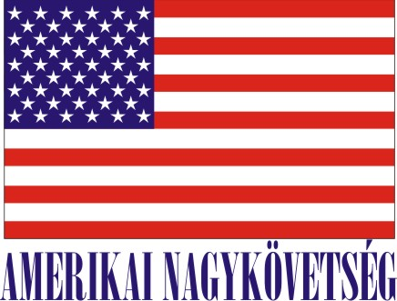 American Embassy Budapest
Local Internship program
(Unpaid internship)
In the Regional Environmental, Science and Technology, and Health Hub Office (ESTH Hub)
In the Fall 2018 Semester
Minimum 4 hours per day or minimum20 hours/week for 2-3 months, with possible extension
The Regional Environmental, Science and Technology, and Health Hub (ESTH Hub Office) has bilateral and regional responsibilities and is one of twelve ESTH Hub Offices that the U.S. State Department has established around the world. Its core mission is to promote U.S. engagement on environmental, scientific, health, and technology issues and to strengthen regional and transboundary cooperation in Central and Eastern Europe, including the Caucasus. The Hub Office covers 20 countries in the region including: Albania, Armenia, Azerbaijan, Belarus, Bosnia and Herzegovina, Bulgaria, Croatia, the Czech Republic, Georgia, Hungary, Kosovo, Macedonia, Moldova, Montenegro, Poland, Romania, Serbia, Slovakia, Slovenia, and Ukraine. The ESTH Hub engages with government officials, NGOs, international organizations, academic and research institutions to advocate U.S. positions on issues such as transboundary water protection, nature conservation, natural resource management, environmental law enforcement, scientific cooperation, and pandemic preparedness.
Major duties and /or projects

- Follow environment, science and technology related articles in the Hungarian press and online media and prepare short summaries
- Follow the development of transboundary environmental and scientific policy issues related to renewable energy policy, water protection, climate change policy and clean technology
- Assist Hungarian and American colleagues as required with identifying, researching, and assessing significant developments in Hungarian politics and economy in the field of energy, biotechnology, health care, science and technology
- Assist with incoming delegations and planning section meetings and visits
- Assist with translation of documents, official Embassy functions, attending and reporting on briefings and meetings
- Assist with the section's outreach efforts to Hungarian policy-makers, scientific and NGO groups, institutions and business partners
Skills and qualifications

- Ability to develop relationships with colleagues at the Embassy and members of the environmental and science communities.
- Desirable Computer skills include strong capability in Word, Excel and Power Point
- Desired language proficiency: English level III/III; Hungarian level III/III.
- Proactive and able to work quickly and independently
- Research and writing skills critical
- Ability to use office equipment (copier, fax machine, scanner)
- Having a background or interest in environmental issues, natural sciences, renewable energy, science, technology, or health is a plus, but not required

How will this internship benefit the section and the intern

The internship program is a great opportunity for a student to work in a professional environment and with skilled American and Hungarian colleagues. The intern can develop communication, business and planning skills, have broad insight into regional environmental and scientific issues, improve their professional language skills, and gain a good introduction to the conduct of international relations. The intern’s support will help ESTH broaden our outreach, planning and research capabilities. The section will also benefit from the intern's fresh academic knowledge and interest in environment, science, technology and health issues.

Certification: The ESTH section would provide the workplace and equipment for the intern to perform their duties during the internship.

Please note that there are no benefits attached to this internship, no compensation nor any future employment rights.

TO APPLY: Please submit application form (to be obtained from the Career Center of the Educational Institution), CV and Statement of Interest to Human Resources Office, American Embassy, Szabadság tér 12. 1054, Budapest, Closing date: May 18, 2018.

