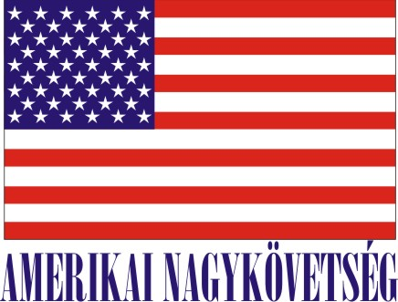
American Embassy Budapest
is seeking a highly motivated student for a
Local Internship
(unpaid internship)
in the Facility Maintenance Section in the Spring 2016

- Duration:
6 weeks (with possible extension), variable hours

- Major duties and/or projects, the scope of work and related duties:

- How will this internship benefit the section and the intern:
The internship program is a great opportunity for the interns to work in a professional environment together with Hungarian and American colleagues. The intern will have an opportunity to master his/her communication skills, to follow and learn the frequently changing laws, regulations and collect information. The FM Section will benefit from the interns’ fresh academic knowledge, their creativity, as well as computer skills.

Certification: The Facility Maintenance Section has the adequate workspace and equipment for the interns to perform the duties during the internship.

TO APPLY: Please submit application form (can be obtained from the Educational Institution), CV and Statement of Interest and certification of active student status to Human Resources Office, American Embassy, Szabadság tér 12. 1054, Budapest or to budapestrecruitment@state.gov. Closing date: December 11, 2015.

