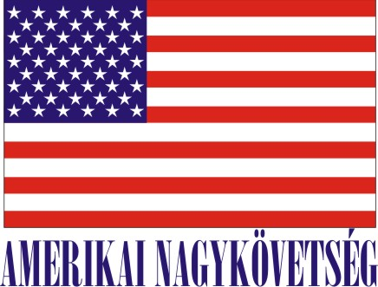
American Embassy Budapest
is seeking a highly motivated student for a
Local Internship
(unpaid internship)
in the Facility Management (FM) Section in the Spring 2018

- Duration:
2 months (with possible extension),
20 hours (3-4 hours per day or every 2nd day, variable hours

- Major duties and/or projects, the scope of work and related duties:
- How will this internship benefit the section and the intern:
The internship program is a great opportunity for the interns to work in a professional environment together with Hungarian and American colleagues. The intern will assist Facility Management Office in miscellaneous office work, will have an opportunity to master his/her communication skills, to follow and learn the frequently changing laws, regulations and collect information. The FM Section will benefit from the interns’ fresh academic knowledge, their creativity, as well as computer skills. Assisting /giving hand to the Facility Management - an intern will learn how Facility works/serves residences /offices such of repairs/schedules/preparation of make ready/housing/ office environment - how U.S. Government works/plans in this very field when Facility Management is tasked.
- Skills/related studies required to perform the internship, including any special requirements/qualifications:
Fluency in English and Hungarian, good communication skills, good interpersonal skills, and computer skills (world/excel, outlook).
Certification: The Facility Management Section has the adequate workspace and equipment for the interns to perform the duties during the internship.

TO APPLY:
Please submit the following to the Human Resources Office, American Embassy, Szabadság tér 12. 1054, Budapest or to budapestrecruitment@state.gov:

- Application form (can be obtained from the Educational Institution),
- CV, and
- Certification of active student status.

Closing date: February 10, 2018.

