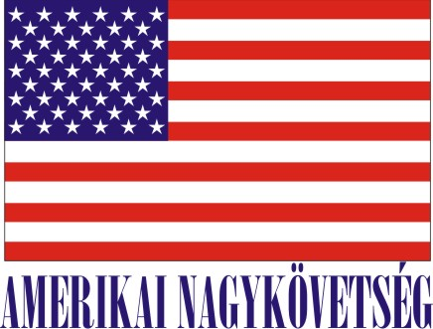
American Embassy Budapest
is seeking a highly motivated student for a
Local Internship
(unpaid internship)
in the General Services Office in the Fall 2018

- Duration:
20 hours per week (variable hours) for approximately 3 months.

- Major duties and/or projects, the scope of work and related duties:
- Assisting in A/LM retagging project where students need to work with excel spreadsheets and assign barcode stickers to furniture and appliances in residences, in offices and in the warehouse.
- Assisting in the annual inventory of Embassy property.
- Assisting in the planning and execution of an online sale of Embassy furniture and equipment.
- Assisting with the scheduling of Property pickup and delivery myServices requests.
- Escorting contractors in residences and in Embassy buildings and reviewing the scheduled work performance of service provider or residential cleaning contractors.
- Conducting market researches on local and US market for furniture and appliances online.
- Assisting in the room setup of official meetings and events in the Chancery meeting rooms.

Required qualifications:

- Language: Hungarian/English (ability to communicate with English speaking customers)
- We are looking for a reliable, organized, customer service oriented team member with good knowledge of Word, Excel and general administrative knowledge. The ability to multi-task and track multi-step issues until their resolution is also important.

- How will this internship benefit the section and the intern:
The intern will get to work in a team environment, utilize their organizational and computer skills and build on their administrative capabilities. This is a great opportunity for someone who would like to gain experience in a professional office environment and for someone with an interest in customer service, supply chain management, logistics and warehousing. The intern will help GSO tackle some of our important projects which will assist us in achieving our department objectives and allow us to maintain high levels of customer service.
Certification: The General Services Office has the adequate workspace and equipment for the intern to perform his or her duties during the internship.

TO APPLY:
Please submit the following to the Human Resources Office, American Embassy, Szabadság tér 12. 1054, Budapest or to budapestrecruitment@state.gov:

- Application form (can be obtained from the Educational Institution),
- CV and
- Certification of active student status.

Closing date: May 18, 2018.

