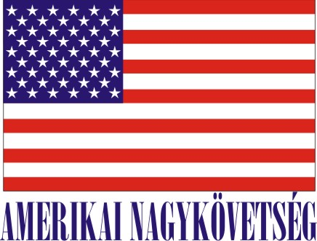
American Embassy Budapest
is seeking a highly motivated student for a
Local Internship
(unpaid internship)
in the Human Resources Office in the Spring 2016

- Duration:
6 weeks (with possible extension), variable hours

- Major duties and/or projects, the scope of work and related duties:
- Collecting labor, social security, visa, recruitment information from the “leader” info websites (origo, index etc)
- Researching governmental websites to confirm the collected information.
- Preparing summaries of the announced and planned changes.
- Assisting in drafting and translating documents.
- Researching possible advertising sources that are free of charge.
- Assisting in drafting vacancy announcements, advertisements.
- Preparing statistics/comparisons regarding various sources of advertising.

- How will this internship benefit the section and the intern:
The internship program is a great opportunity for the interns to work in a professional environment together with Hungarian and American colleagues. The intern will have an opportunity to master his/her communication skills, to follow and learn the frequently changing laws, regulations and collect information. The HR Office will benefit from the interns’ fresh academic knowledge, their creativity, as well as computer skills.

Certification: The Human Resources Office has the adequate workspace and equipment for the interns to perform the duties during the internship.

TO APPLY: Please submit application form (can be obtained from the Educational Institution), CV and Statement of Interest and certification of active student status to Human Resources Office, American Embassy, Szabadság tér 12. 1054, Budapest or to budapestrecruitment@state.gov. Closing date: December 11, 2015.

