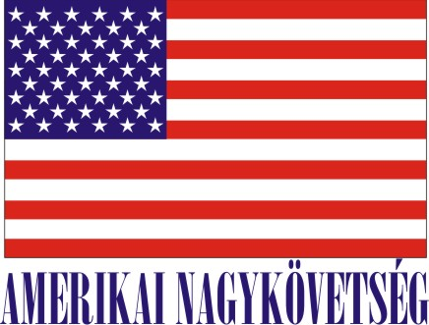
American Embassy Budapest
is seeking a highly motivated student for a
Local Internship
(unpaid internship)
in the Office of Information Resource Management for Spring 2018

- Duration:
3 months, 20 hours / week (with possible extension), variable hours

- Major duties and/or projects, the scope of work and related duties:
The internship involves administrative duties in the management of Embassy Budapest’s unclassified
projects and programs, to include:
. Basic systems administration in Microsoft Active Directory on the Department’s Open Net Plus
network
. Facilitating user account creation and transfers with the IT Service Center
. Monitoring and taking action on Information Management-related taskers assigned through the MyServices portal
. Assisting with Unclassified Mail and Pouch operations, as needed
. Assisting with Information Management-related property transfers and inventories
. Assisting with special projects, per direction of the Information Management Officer-

Required qualifications:
- Language: 3/3 English
- Knowledge, abilities and skills required: Currently pursuing a degree in Information Technology, e.g., Computer Science, Information Management, etc.

- How will this internship benefit the section and the intern:
The internship program is a great opportunity for the interns to work in a professional environment together with Hungarian and American colleagues. An intern would directly benefit the Information Resource Management office through the accomplishment of myriad projects/programs under the IM portfolio. Most notably, assistance with unclassified operations and managing post’s systems. The intern would likewise benefit from gaining knowledge and skills in an active technology environment working alongside Hungarian and American colleagues with decades of professional experience.
Certification: The Human Resources Office has the adequate workspace and equipment for the interns to perform the duties during the internship.

TO APPLY:
Please submit the following to the Human Resources Office, American Embassy, Szabadság tér 12. 1054, Budapest or to budapestrecruitment@state.gov:

- Application form (can be obtained from the Educational Institution),
- CV and
- Certification of active student status.

Closing date: February 10, 2018.

