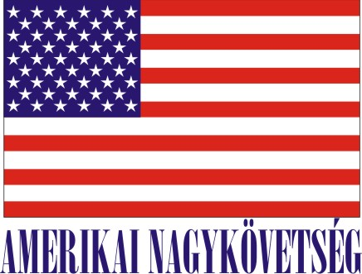
American Embassy Budapest
is seeking a highly motivated student for a
Local Internship
(unpaid internship)
in the Office of Defense Cooperation (ODC) in the Spring 2019

- Duration:
6 weeks (with possible extension), variable hours
- Major duties and/or projects, the scope of work and related duties:
- Assist in planning and organizing Cultural Understanding and Leadership Program visit and English
language program
- Coordinate monthly joint HU-US Security Cooperation Working Group meetings
- Coordinate logistic and support details for military-to-military events and Distinguished Visitors visits
- Assist with joint HU-US exercise support, including Heavy Airlift Wing’s 10thanniversary coordination
- Assist with logistics agreement process, including translation and ensuring package completeness
- Assist with developing and implementing civil outreach, public diplomacy, and public affairs plans and
products in support of bilateral military events and exercises
- Monitoring military social media sites (official, blog, etc) for developments that impact ODC planning
processes
- Assist US Liaison Officers with translation of correspondence
- Assist with military student support, including processing visa paperwork, researching travel options,
managing student books/files

- How will this internship benefit the section and the intern:
The internship program is a great opportunity for the interns to work in a professional environment with Hungarian and American civilians and military members. The intern will have an opportunity to master communication skills, improve customer service skills, learn long- and short-term planning and gain insight into US and Hungarian militaries. The intern can gain practical knowledge of foreign military assistance, foreign military sales, military education and training, and foreign/defense policy development/ implementation. The Office of Defense Cooperation will benefit from the intern’s fresh academic knowledge, creativity, and computer skills.
Certification: The Office of Defense Cooperation has the adequate workspace and equipment for the interns to perform the duties during the internship.

TO APPLY:
Please submit the following to the Human Resources Office, American Embassy, Szabadság tér 12. 1054, Budapest or to budapestrecruitment@state.gov:

- Application form (can be obtained from the Educational Institution),
- CV and
- Certification of active student status.

Closing date: December 14, 2018.

