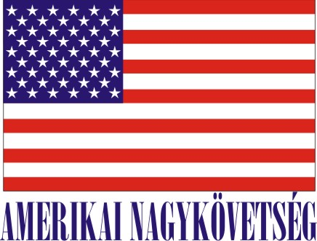
Embassy of The United States of America
Budapest, Hungary
is seeking a university or graduate student for a
Local Internship
in the Public Affairs Office for the Spring/Summer 2016 semester

- Number of hours/day:

15-20 hours per week for 16 weeks, extendable to 24 weeks

- Description of duties:

Assist the press and online media team with programs, events, and initiatives. This may include identifying and developing content for the Embassy’s multiple online platforms, participation in youth outreach campaigns, research projects, press monitoring and analysis, English-to-Hungarian translation, administrative tasks, and other duties as needed.

- Skills/related studies required to perform the internship, including any special requirements/qualifications:
Fluency in English and Hungarian, good communication skills, knowledge of the United States, knowledge of world affairs and current events, good interpersonal skills, and experience in using social media.
- How will this internship benefit the section and the intern:
The section benefits from the diversity of opinion and outlook brought by an intern; the student benefits from the exposure to international affairs and gains experience working in an international environment. The student will also gain experience in working with online media in a professional capacity.
Certification: The Public Affairs Office has adequate workspace and equipment.

TO APPLY: Please submit application form (can be obtained from the Educational Institution), CV and
Statement of Interest to : Human Resources Office, American Embassy, Szabadság tér 12. 1054, Budapest
Closing date: December 11, 2015.

