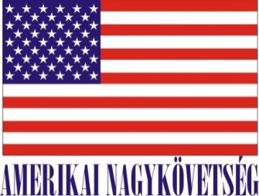
Embassy of the United States of America
Budapest, Hungary
is seeking university students for a
Local Internship
in the Public Affairs Office for the Spring 2020 semester
- Number of hours/day:
16-20 hours per week for 12 weeks, extendable to 24 weeks

- Description of duties:

Assist the cultural, press, and online media teams with programs, events, and initiatives. This may include identifying and developing content for the Embassy’s multiple online platforms, participation in youth outreach campaigns, research projects, press monitoring and analysis, English-to-Hungarian translation, administrative tasks, and other duties as needed.

- Skills/related studies required to perform the internship, including any special requirements/qualifications:

Fluency in English and Hungarian, good communication skills, knowledge of the United States, knowledge of world affairs and current events, good interpersonal skills. Familiarity with Embassy social media activity (Facebook, Twitter, YouTube), and experience in generating content for social media. Video production and photo editing skills are a plus, but not required.

- How will this internship benefit the section and the intern:
The Office benefits from the diversity of opinion and outlook brought by an intern; the student benefits from the exposure to international affairs and gains experience working in an international environment. The student will also gain experience in working with online media in a professional capacity.
Certification: The Public Affairs Office has adequate workspace and equipment.

How you apply:
Submit your application form (obtained from your university) along with your CV, Statement of Interest, and certification of active student status to the Human Resources Office at the American Embassy, Szabadság tér 12. 1054, Budapest or to budapestrecruitment@state.gov.
Closing date: January 24, 2020.
Please note this internship is unpaid.

