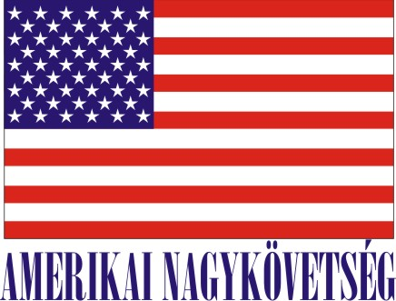
American Embassy Budapest
is seeking a highly motivated student for a
Local Internship
in the Protocol Office in the Spring 2019 semester

- Duration:
6 weeks (with possible extension), variable hours

- Major duties and/or projects, the scope of work and related duties:
- Translates and summarizes protocol-related correspondence including invitations in Hungarian
- Maintains log of invitations, keeps record of each invitation, follows up with the relevant offices regarding the invitation
- Coordinates all protocol aspects with mission personnel regarding their attendance when they are attending an event on the Ambassador’s behalf
- Handles incoming phone calls and emails with tact and discreetly in close supervision
- Assists with preparation of guest lists, enters data
- Escorts high level contacts of the Executive office

- How will this internship benefit the section and the intern:
The internship program is a great opportunity for the interns to work in a professional environment together with Hungarian and American colleagues. The intern will have an opportunity to master his/her communication skills, learn how the embassy Protocol office operates, learn the rules of the Hungarian and the American Protocol, also will gain knowledge how diplomatic and international relations work in the aspects of protocol. The Protocol Office will benefit from the interns’ fresh academic knowledge, their creativity, fresh ideas as well as computer skills.

Certification: The Protocol office would like to use one of the workplaces set up for the interns on the 1st floor in order to be able to perform the duties during the internship.

TO APPLY: Please submit application form (can be obtained from the Educational Institution), CV and Statement of Interest to Human Resources Office, American Embassy, Szabadság tér 12. 1054, Budapest, Closing date: December 14, 2018.

