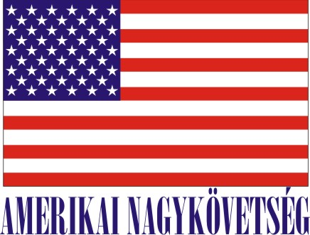
American Embassy Budapest
is seeking a highly motivated student for a
Local Internship
Protocol Office

- Duration:
6 weeks (with possible extension), variable hours
preferably 1st or 2nd year students

- Major duties and/or projects, scope of work and related duties:
- Translate and summarize protocol-related correspondence including invitations in Hungarian;
- Maintain log of invitations, tracks responses;
- Respond to incoming phone calls and emails with tact and discretion;
- Assist with date input for upcoming guest lists;
- Research updated biographic data for official meetings;
- Be aware of current cultural programs, new restaurant openings and current personalities;
- Provide protocol assistance at official Embassy events.

- How will this internship benefit the section and the intern:
The internship program is a great opportunity for the interns to work in a professional environment together with Hungarian and American colleagues. The intern will have an opportunity to improve communication skills, learn how the embassy Protocol office operates, learn the rules of Hungarian and American Protocol, and start to understand the protocol aspect of diplomatic and international relations. In turn, Protocol Office will benefit from the current academic knowledge, creativity, fresh ideas and advanced computer skills that a young intern would bring.

Certification: The Protocol Section requests use of one of the available 1st floor working stations to accommodate this.

TO APPLY: Please submit application form (can be obtained from the Educational Institution), CV and Statement of Interest and certification of active student status to Human Resources Office, American Embassy, Szabadság tér 12. 1054, Budapest or to budapestrecruitment@state.gov. Closing date: December 11, 2015.

